**Follow-Up Report**

**Submitted by**

**Imperial Community College District**

**380 East Aten Road**

**Imperial, CA 92251**

**Submitted to:**

**Accrediting Commission for Community and Junior Colleges**

**Western Association of Schools and Colleges**

**March 15, 2015**

# CERTIFICATION OF THE ACCREDITATION FOLLOW-UP REPORT

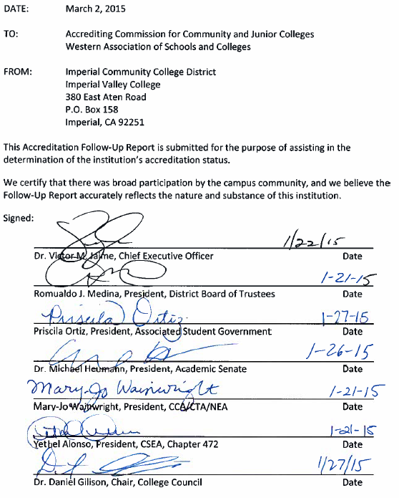

**TABLE OF CONTENTS**

CERTIFICATION OF THE ACCREDITATION FOLLOW-UP REPORT 2

STATEMENT ON REPORT PREPARATION 4

RESPONSE TO RECOMMENDATION ONE 10

RESPONSE TO RECOMMENDATION EIGHT 28

***A list of evidence, with hyperlinks to each item, is provided at the end of each section.***

# STATEMENT ON REPORT PREPARATION

**District Preparation**

The External Evaluation Team visited Imperial Valley College on April 14, 2014, to evaluate the College’s response to the Follow-Up Report submitted March 2014. In May 2014, Superintendent/President Dr. Victor Jaime held a forum to inform the campus community of the anticipated accreditation status of the College and that formal notification would be made in July.[1] Shortly thereafter, the CIO/ALO and CART Executive Team met to develop a preliminary timeline for completing the anticipated follow-up report.[2] On July 3, 2014, the Accrediting Commission for Community and Junior Colleges (ACCJC) formally informed the College of the continued warning sanction due to the two remaining recommendations and directed the College to complete a Follow-Up Report by March 15, 2015.[3] In July 2014, report writing teams, readers and editors from the 2014 Follow-Up Report were reinstated and the preliminary timeline was updated and distributed.[4] In addition, a status report was made to the Board by the new CIO/ALO.

First drafts of responses to the recommendations were submitted by the teams in early October 2014, forwarded to the assigned readers, and then returned to the originating team for revision and/or requests for more evidence as necessary prior to final editing. Routine progress reports were disseminated to the campus community through distribution of CART meeting minutes[5] and standing reports at participatory governance committees.[6]

The reading and approval of the final document was completed by the Academic Senate on December 10, 2014;[7] College Council on January 5, 2015;[8] President’s Cabinet on January 6, 2015;[9] and the Board of Trustees on January 21, 2015.[10]

**Working Groups**

The College formed two working groups to address the recommendations and the teams are listed below:

**Recommendation 1**:

Ted Ceasar, Dean of Counseling (Team Lead)

Efrain Silva, Dean of Economic and Workforce Development

Frank Hoppe, Reference Librarian

Terry Norris, Reading/Writing Lab Tutorial Specialist

Jose Carrillo, Director of Institutional Research

**Recommendation 8**:

John Lau, Vice President for Business Services (Team Lead)

Mary Carter, Administrative Assistant to the Vice President for Business Services

Dave Drury, Exercise Science/Wellness/Sport Department Chair/PE Faculty

Matthew Thale, Systems Analyst

Melody Chronister, Publication and Academic Systems Specialist

Kevin White, Behavioral and Social Sciences Department Chair/Political Science Faculty

Craig Blek, Business Department Chair/Economics Faculty

**Editors and Readers:**

Dr. Nicholas Akinkuoye, Vice President for Academic Servicers, ALO

Brian McNeece, former Dean of Arts, Letters and Learning Services, current ESL Instructor, CART Co-Chair

Tina Aguirre, Dean of Health and Science, CART Co-Chair

Linda Amidon, Administrative Assistant to the Vice President for Academic Services/ALO

Adriana Sano, Administrative Assistant to the Vice President for Student Services, Technology, and Research

Mary Carter, Administrative Assistant to the Vice President for Business Services

**Technical and Graphic Support:**

Mike Nicholas, Publications Design Coordinator

Matthew Thale, Systems Analyst

Alejandro Aguilar, Senior Computer Programmer Systems Analyst

**Timeline of Activities**

Prior to and following the receipt of the ACCJC’s ruling, several key events took place. Following is a timeline of these events.

April 2014

* External Evaluation Team visits the College

May 2014

* Superintendent/President holds forum to inform campus community of the anticipated accreditation status and that formal notification would be made in July
* Then CIO/ALO Kathy Berry and the CART Executive Team meet and formulate a preliminary timeline
* On-site training on Strategic Planning Online (SPOL) for Deans, Chairs, Program Heads, and support staff is provided by the SPOL Consultant
* Department budget reviews are conducted

June 2014

* Budget and Fiscal Planning Committee (BFPC) prioritizes 2014-2015 resource requests from 2013-2014 program review
* BPFC approves the tentative 2014-2015 budget and forwards to President’s Cabinet
* Board approves 2014-2015 tentative budget
* Then CIO/ALO Kathy Berry and the CART Executive Team review accreditation status and preliminary timeline for Follow-Up report with new CIO/ALO Dr. Nicholas Akinkuoye (official start date July 1, 2014)
* President’s Cabinet receives preliminary timeline and is introduced to proposed online calendar
* 2013-2014 program reviews are loaded into SPOL as a test
* Academic program review data task force confirms configuration of data for program reviews to be completed in 2014-2015

July 2014

* Program review templates are reviewed for alignment with SPOL
* Dr. Nicholas Akinkuoye officially begins his duties as CIO/ALO
* Superintendent/President receives notification from ACCJC regarding the College’s accreditation status as Continue on Warning
* Superintendent/President informs the Board of Trustees that the Commission has met and the College has been notified that ACCJC has placed the College on a Warning Sanction based on two recommendations. A Follow-Up Report will be due to the Commission on March 15, 2015. The Board is also informed that the college community has begun reviewing the recommendations
* Follow-Up Report teams, readers, and editors are reinstated and adjusted timeline is distributed
* CIO/ALO Dr. Akinkuoye provides Accreditation Status Report to the Board
* Instructional Deans and Director of Institutional Research receive training on loading program reviews in SPOL
* Instructional Deans provide training to support staff on data entry of 2013-2014 program reviews in SPOL
* 2014-2015 academic program review template is revised further to align with SPOL
* Committee Self-Evaluation form is distributed to Academic Senate sub-committees for completion
* President’s Cabinet approves BFPC prioritization on program review enhanced budget requests for 2014-2015 tentative budget

August 2014

* Jill Nelipovich is appointed as SLO Coordinator to replace Sydney Rice
* 2014-2015 service area program review template is revised to align with SPOL
* The Follow-Up Report timeline is further updated; preliminary timelines for program review/planning and 2016 Mid-term Report are developed
* Director of Institutional Research distributes data to programs to begin 2014-2015 program review and planning cycle
* Academic department chairs and coordinators receive training on 2014-2015 academic program review template and process
* Support staff continues data entry of 2013-2014 program reviews in SPOL
* A Board Retreat is held and CBO provides presentation on status of response to Recommendation 8 and to address categorical program funding
* The Educational Master Planning Committee (EMPC) reviews goals and objectives and completes evaluation of 2013-2014 program review and planning cycle
* Board reaffirms strategic EMP, resource plans, approves assessment of institutional effectiveness, and sets goals for 2014-2015
* SLO/PLO Data is uploaded into SPOL and an Assessment Guidebook is developed for training faculty; training schedule is developed and implemented
* SLO Committee forwards revisions to the Institutional Learning Outcomes to the Curriculum Committee
* Brian McNeece, former Dean of Arts, Letters, and Learning Services and current ESL instructor, is appointed as Accreditation Coordinator
* Committee Self-Evaluation form is distributed to College Council sub-committees for completion

September 2014

* BFPC approves 2015-2016 budget guidelines and principles for distribution to campus community
* Board approves 2014-2015 final budget
* 2014-2015 program reviews are completed (paper process)
* Data entry of 2014-2015 program reviews into SPOL including goals and budget begins
* The Follow-Up Report Timeline is updated further
* Schedule development process begins for 2015-2016 annual schedule
* Recommendation 1 and Recommendation 8 teams work on responses
* President’s Cabinet approves use of online calendar and authorizes users to begin entering events
* SPOL trainings continue for SLO/PLO cycle assessment data entry
* The Curriculum Committee approves the SLO Committee ILO revisions for inclusion in the 2015-2016 catalog
* College Council approves sub-committee self-evaluations

October 2014

* A Board Retreat is held and EMPC Co-Chairs provide presentation on status of response to Recommendation 1
* 2015-2016 schedule development ends and faculty selection begins (deadline Nov. 21)
* First drafts of responses to Recommendation 1 and Recommendation 8 distributed for review
* Instructional Council and Student Services Council completes prioritization of new faculty positions
* Data entry of 2014-2015 program reviews into SPOL is completed
* Deans and VPs approve 2014-2015 program reviews and budgets in SPOL
* SPOL trainings continue for SLO/PLO cycle assessment data entry; meetings held with SPOL programmers to address concerns from training sessions

November 2014

* Faculty selection for 2015-2016 annual schedule continues
* Instructional Council prioritizes replacement faculty positions
* Enhanced budget requests by resource plan are distributed to resource plan committees
* Resource planning committees prioritize enhanced budget requests and forward to BPFC
* The Staffing Committee prioritizes staffing positions from 2014-2015 program review and submits to President’s Cabinet
* Editor completes review of 2015 Follow-Up Report
* College Council reviews draft Follow-Up Report (first reading)
* SPOL trainings continued for SLO/PLO cycle assessment data entry
* Academic Senate summary of sub-committee self-evaluations is submitted to EMPC
* Student surveys are conducted by CART and ATLAS

December 2014

* BPFC prioritizes enhanced budget requests received from resource plan committees and makes recommendation to President’s Cabinet
* President’s Cabinet makes a final decision on prioritization of faculty and staff positions
* EMPC evaluates 2014-2015 program review and planning cycle
* President’s Cabinet reviews draft Follow-Up Report
* Faculty completing SLOs, in particular courses, should have their data entered into SPOL
* Academic Senate accepts the Follow-Up Report

January 2015

* College Council accepts the Follow-Up Report
* President’s Cabinet accepts the Follow-Up Report
* The Board of Trustees certifies the Follow-Up Report
* Programs conduct mid-year review of 2014-2015 goals (SPOL Objectives)
* Development of preliminary 2015-2016 budget is in progress

February 2015

* The Superintendent/President holds campus forums on Accreditation Follow-Up Report

March 2015

* The Follow-Up Report is submitted to ACCJC

**REPORT PREPARATION EVIDENCE**

# RESPONSE TO RECOMMENDATION ONE

**Recommendation 1: In order to fully meet the Standard, the team recommends that the College consistently link the institutional goals and objectives detailed in the Educational Master Plan with operational plan goals and resource allocations, including technology resources, in order to assess progress toward meeting institutional goals. In addition, the College should establish a planning calendar that identifies all planning activities, committees, and the roles of various College plans, and includes institutional effectiveness assessment and improvement cycles. (I.B .3, II.C.1b, IV.A.5)**

**INTRODUCTION**

This follow-up report responds to the ACCJC letters of May 6 and July 3, 2014[11] and provides evidence that Imperial Valley College (hereafter known as the College) has implemented the policies, provisions, and practices required for full compliance with the accreditation standards for a California community college. The College has performed the corrective measures identified by the Commission to attain full accreditation and be relieved of its current warning status.

An External Evaluation Team visited the College in March 2013, to validate the College’s comprehensive self-evaluation, and found the College deficient in a number of accreditation standards. More specifically, Recommendation 1 identified the following deficiencies:

**“In order to fully meet the Standard, the team recommends that the College consistently link the institutional goals and objectives detailed in the Educational Master Plan with operational plan goals and resource allocations, including technology resources, in order to assess progress toward meeting institutional goals. In addition, the College should establish a planning calendar that identifies all planning activities, committees, and the roles of various College plans, and includes institutional effectiveness assessment and improvement cycles” (I.B .3, II.C.1b, IV.A.5).”**

As required by the Commission, the College submitted a follow-up report in March of 2014 addressing the deficiencies identified by the visiting team. A second External Evaluation Team visited the College in April 2014 to evaluate the College’s response and follow-up report. In assessing the College’s response to Recommendation 1, the External Evaluation Team concluded that the College had made “notable efforts to thoroughly address the recommendation to consistently link its institutional goals to operational plan goals and resource allocations.” The following efforts were noted:

* The promotion of SMART goals (specific, measurable, attainable, relevant, and time-limited).
* The creation of a program review template that linked institutional goals to student success and College priorities.
* The adoption of a strategic planning online system (SPOL) to integrate program review, student learning outcomes, and planning and budgeting.
* The development of a Program Review Handbook to standardize the review process.
* The revitalization of a decision-making structure by linking the College’s mission statement and institutional goals through an integrated planning process and collegial consultation.
* The adoption of a comprehensive planning calendar that describes all planning cycles.

Within the External Evaluation Team report, issues were identified that, although not specifically mentioned in the Team’s conclusion, merited mitigation by the College. These issues included:

* The full implementation of SPOL to integrate program review, learning outcomes, and planning and budget in support of progress on College goals and overall institutional effectiveness.
* The migration of all processes into SPOL by fall 2014 for the information to be used in the 2015-2016 program review.
* The need to make committee participation broader and more robust.
* The need for a process to include an evaluation of outcomes from program linkages and resource allocations.
* The assessment of improvements with respect to institutional effectiveness and student success.
* The need to track improvements in student achievement and progress on institutional goals.
* The alignment of institutional assessments with either annual reviews or three-year educational master planning process.
* The use of SPOL to close the loop on the assessment cycle and to identify, record, and use assessments for institutional improvement.

The External Evaluation Team, based on their findings and evidence provided by the College, concluded the following:

**“The college has made significant progress with this Recommendation and is largely compliant with the standards on which it is based. Assessment of the current Institutional Goals and Objectives should occur as a part of the May EMPC meeting. In order to be fully compliant, the College needs to complete a cycle of assessment and show how results were used in the next year’s planning and allocation of resources. The continued setup and use of the SPOL instrument will help tremendously in accomplishing this goal.”**

This report focuses on the mitigation efforts that support the Team’s conclusion, as well as the peripheral issues identified by the External Evaluation Team. Items previously cleared by the Commission are not addressed in this report. The College also assumes that other Recommendation 1 requirements not identified in the report have already been met.

The College has addressed all of the External Evaluation Team’s findings and the Commission’s recommendations. A full assessment cycle has been completed with processes that link planning and resource allocation to Institutional Goals through the following efforts:

**IMPLEMENTATION OF STRATEGIC PLANNING ONLINE (SPOL)**

**Completing a Cycle of Assessment**

**“The college needs to complete a cycle of assessment and show how the results were used in next year’s planning and allocation of resources. The continued setup and use of the SPOL instrument will help tremendously in accomplishing this goal” (Report of the External Evaluation Team, May 6, 2014).**

In order to link planning to budget development, Imperial Valley College did a full implementation of Strategic Planning Online (SPOL) for its 2014-2015 Program Review and Planning Cycle. SPOL provides a dynamic, coherent online platform to support unit-based strategic planning; budget planning; accreditation compliance; and assessment of outcomes of student learning, programs, and operations. SPOL provides integration of four key modules (planning, assessment, accreditation, and budget), which creates a solid framework for a cyclical process to assess and monitor institutional effectiveness (SPOL video demonstration, <http://spaces.imperial.edu/omar.ramos/videos/using_spol_to_integration_all_aspects_of_institutional_effectiveness.mp4>).

The basic building block of SPOL is a planning unit, through which faculty, staff, and administration in academic and service areas input their yearly objectives, tasks, and funding needs. Through SPOL, the activities of each planning unit are integrated up the organizational structure (e.g. department, division, area) via approval chains, and comprehensive reporting. Planning objectives and their associated tasks are aligned with accreditation standards and linked to institutional goals.

SPOL supports a methodology of budget preparation that divides the operating budget into two distinct parts: base budget and enhanced budget. Through program review, when a planning unit’s base budget is inadequate to fund these activities and strategies, the unit manager has the opportunity to request enhancement funding.

**Base Budget**

Each planning unit requires a base budget to operate at normal levels of operation. This includes figures from the last two years to ensure that all budget planning is based on historical data as a point of reference (Figure 1). The base budget amount will change, dependent on factors such as changes in staffing levels prompted by retirements, new hires, and adjustment in course offerings as dictated by discussions within the processes outlined in the Enrollment Management Plan.[12]

Figure 1. SPOL Budget Detail Page

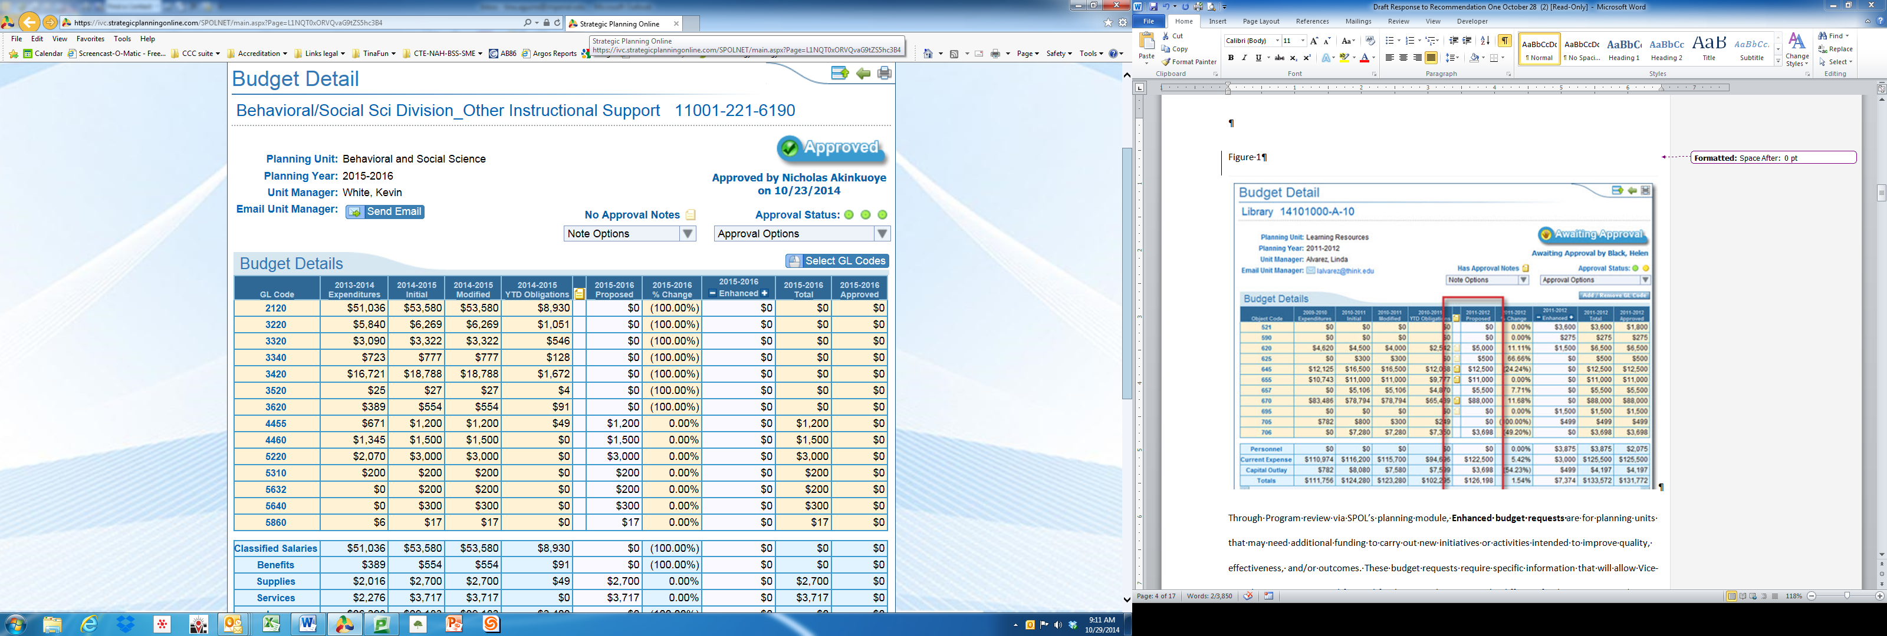

**Enhanced Budget**

Enhanced budget requests are submitted by planning units that may desire additional funding to carry out new initiatives or activities intended to improve quality, effectiveness, and/or outcomes. These enhanced budget requests require specific information, or justification, that will inform the shared governance process to authorize or reject and forward funding considerations to the resource plan committees (Figure 2).

Figure 2. SPOL Enhanced Budget – Forecasted Detail

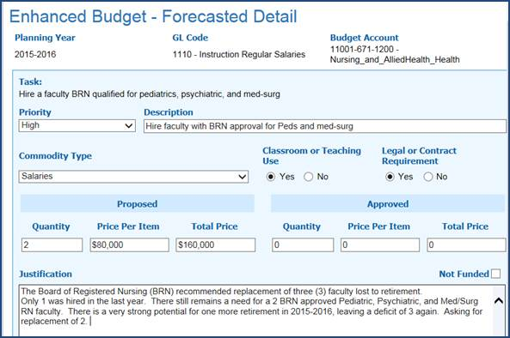

SPOL also allows planning units to forecast into future years for adequate planning. Linking budget development and planning is possible through SPOL (Figure 3).

Figure 3. SPOL Proposed Budget – Forecasted List

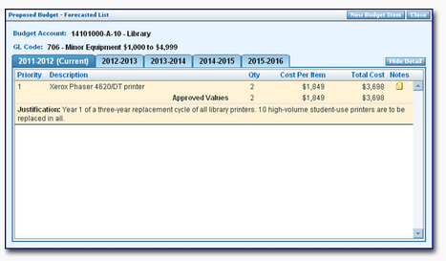

**SPOL Implementation Process and Timeline**

The College created a SPOL implementation team composed of representatives from each area on campus. Training began in July 2013. Countless hours were dedicated to setting up SPOL to meld the College’s current processes (program review, student learning outcomes, budget, etc.) with the architecture of SPOL and accurately reflect the ongoing work of linking planning to resource allocation. Below is the timeline of the trainings, webinars, and small group planning and training sessions that took place in preparing staff to fully implement SPOL.

|  |  |
| --- | --- |
| **Date** | **Training Topics** |
| 7-29-13 | Introductions and SPOL Overview |
| 8-5-13 | Planning Module Review |
| 8-12-13 | Assessment Module Review; Creating Outcomes, & Overview of Reports |
| 8-19-13 | Setting-up Planning Units; Creating Set-up for Warning-Follow Up Report |
| 9-2-13 | Budget Module Review |
| 9-6-13 | Budget Set-up Discussion |
| 9-9-13 | Accreditation Module Review – Setting up Standards |
| 9-16-13 | Accreditation Module Review – Planning Cycles |
| 9-23-13 | Budget Module and Accreditation Set-up |
| 10-7-13 | Planning Module – Creating Objectives |
| 10-14-13 | Accreditation – Linking to Document Repository |
| 10-21-13 | Review of Objective and Assessment Reporting Capabilities |
| 10-28-13 | Discussion of Integration of Different Planning Cycles onto SPOL |
| 11-4-13 | Accreditation: Setting up a Program Review Cycle |
| 11-18-13 | Program Review Process |
| 2-2-13 | Setting up Assessment Module |
| 1-6-14 -- 4-7-14 | SPOL User Trainings, Implementation, Service Area Program Review, Budget |
| 5-21-14 -- 5-22-14 | SPOL Onsite Training for Academic and Service Area Program Review |
| 7-8-14 | SPOL Training – Aligning SPOL to Program Review with Dept. Chairs/Deans |
| 7-16-14 -- 8-7-14 | Planning, Accreditation, and Assessment Set-up Meetings with vendor |
| 08-13-14 | SPOL System Administration Training |
| 8-27-14 | Service Area Program Review Template Session |
| 8-29-14 | SPOL Budget Set-Up Conference Call |
| 9-12-14 -- 9-30-14 | SPOL Basics and Program Review (9 trainings) |
| 9-29-14 -- 9-30-14 | Program Review and Budget Trainings (6 trainings) |

Setting up SPOL to reflect the College’s organizational structure and processes fully was a massive undertaking. The SPOL Implementation Team and then others entered all users with appropriate access roles, ACCJC standards, institutional goals, student learning outcomes, courses, faculty information, general ledger and account codes, and budget data for the past three years. All of this information has created a comprehensive look at planning, assessment, and budgeting, which will also build the future self-evaluation report for accreditation.

The implementation of SPOL has created an opportunity for the College to streamline all three processes of program review, budget planning, and Student Learning Outcomes mapping and tracking. SPOL implementation has been very laborious as it required the transition of program review and related processes from paper-based planning to electronic web-based planning. Despite formidable obstacles, the College staff have embraced the challenge as an ongoing effort because it continues to improve the linkages across all areas and all levels of the organizational structure.

**CAMPUS COMMITTEES**

The College has recently instituted and completed a comprehensive cycle of committee self-evaluations, including an analysis of evidence related to attendance, committee composition, objectives proposed, and objectives achieved.[13] As a result, several committees have been streamlined; other committees may be dissolved or repurposed. New committees may be formed. This cycle of committee self-evaluation will now become annual.[14] [15]

The Academic Senate solicited self-evaluations from each sub-committee and has reported a summary back to the campus community.[16] In response to the ACCJC recommendation, the Academic Senate has taken strong steps to facilitate broader and more robust participation at these collegial consultation committee meetings. As a direct result of these efforts, 100% of new faculty have been added to the rosters of Academic Senate committees. Some limited openings at Academic Senate committees drew a large number of candidates–more than 15 candidates for two openings on the Distance Education Committee. New faculty and faculty without committee appointments are given priority over other candidates when committees are constituted. Committee members with spotty attendance may be relieved of their committee membership to make way for more committed members.

The College Council is conducting a review of the campus committees aligned under it using the committee self-evaluation tool. All committees completed and submitted self-evaluations to the College Council, which will review them for membership and participation. Representative groups will be asked to replace low-attending members.[17]

Through participatory governance, the College will implement in 2015-2016 a new Campus Hour that will ensure better participation at all planned committee meetings and other events on campus. Surveys have shown that the biggest barrier to attendance at department and committee meetings is scheduling conflicts. By establishing an hour free of all classes Monday through Thursday, from 12:50 to 1:50 p.m., the College removes this objection to attendance at meetings, professional development, or other campus events.[18]

The EMPC and CART worked together to approve new bylaws that streamline committee membership and establish a consultant role. In addition, the new bylaws offer better representation across campus that engage a wider band of staff, including teaching faculty and others. With these changes, the College expects more robust attendance and participation.[19]

**PLANNING CALENDAR**

During the 2013-2014 academic year the College established an improved planning calendar that identified all planning activities, committees, and the roles of various College plans, and included institutional effectiveness assessment and improvement cycles.[20] However, it became obvious that this calendar, in the form of a static document, was difficult to locate and use. Additionally, the static calendar was not integrated with other campus events. To remedy these defects, a new dynamic online calendar was implemented in September of 2014 (<http://teamup.com/ksc1bb71d5d0db3b1f/>). Utilizing the TeamUp software, the calendar is now accessed from the College’s home page. TeamUp is a shared calendar application for groups and projects, making it easy for any group (department, program, committee, club) to be organized and stay informed of the status of group activities or resource availability at any specific time.

The TeamUp calendar was primarily chosen because of its “no-user-account approach” and unique scheme for sharing one or multiple calendars via a single "secret" link. Compared to other solutions, which usually require a fairly complicated plan for controlling access to editing rights on the calendar, TeamUp provided a happy medium for editing access to one or more calendars to many users on campus in a way that still allowed for a publicly accessible online calendar.

This allowed the College to create a unique editing URL and share that with, for example, the Athletics staff to enter information about upcoming games and have that be a part of the larger multiple calendar. Since the College also has a calendar for all of its planning and program review events and deadlines, the user can also switch to TeamUp’s “Agenda” view and filter things so that only that particular calendar’s events are displayed, including a quick summary page that can easily be printed (Figure 4 and Figure 5).

Figure 4. Teamup Calendar

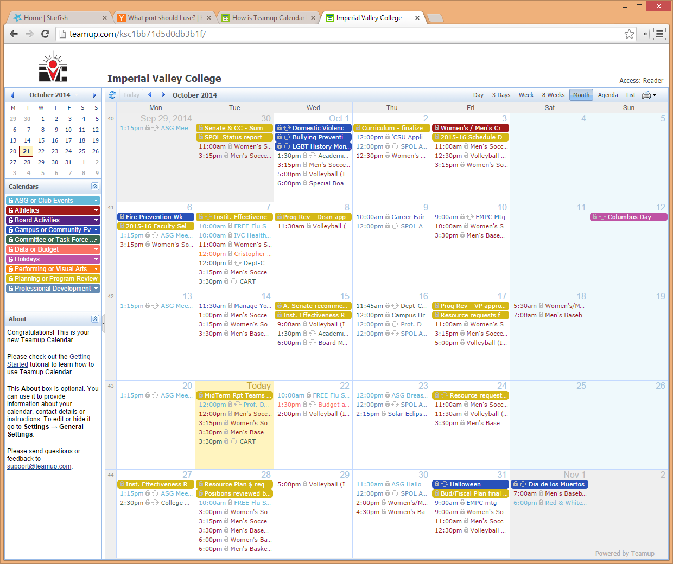

Figure 5. Teamup Calendar, Agenda View

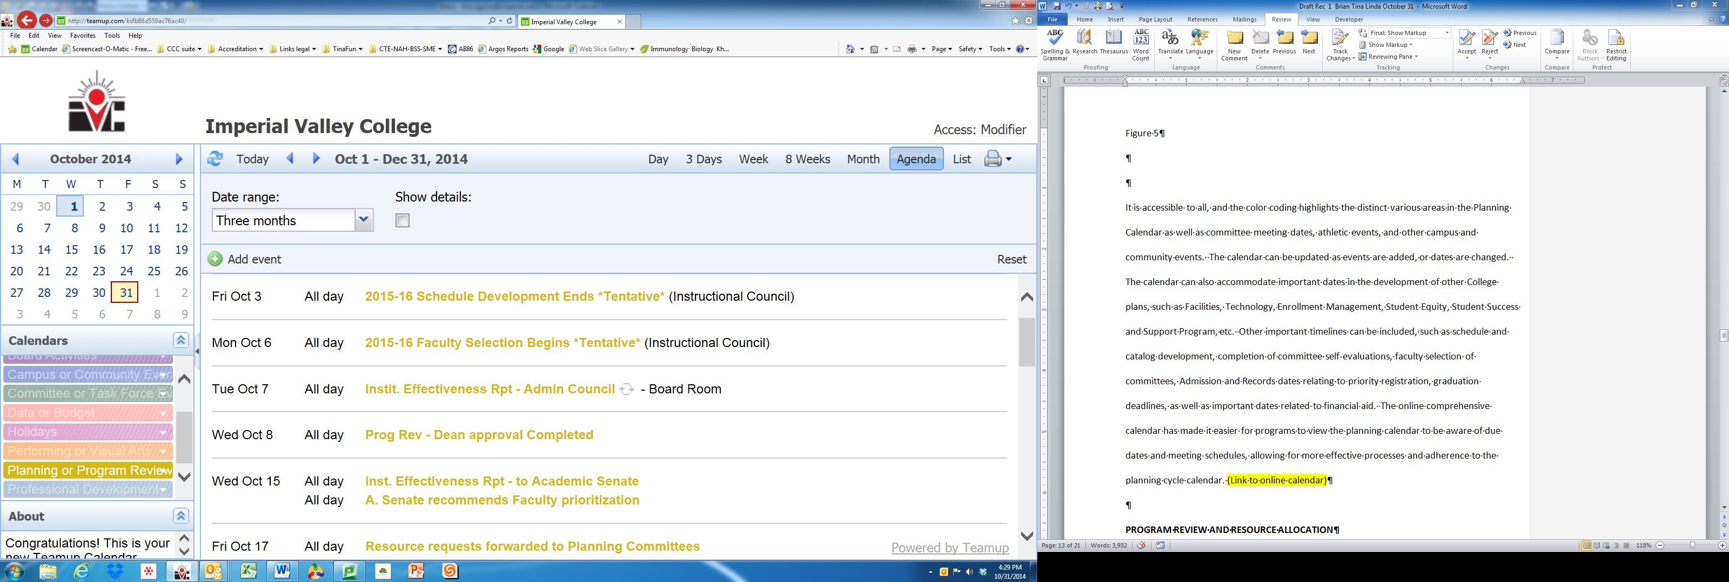

The online calendar is accessible to all, and the color coding highlights the distinct various areas in the planning calendar as well as committee meeting dates, athletic events, and other campus and community events. The calendar can be updated as events are added or dates are changed. The calendar can also accommodate important dates in the development of other College plans, such as Facilities, Technology, Enrollment Management, Student Equity, Student Success and Support Program, etc. Other important timelines can be included, such as schedule and catalog development, completion of committee self-evaluations, faculty selection of committees, Admission and Records dates relating to priority registration, graduation deadlines, as well as important dates related to financial aid. The online comprehensive calendar has made it easier for programs to view the planning calendar to be aware of due dates and meeting schedules, allowing for more effective processes and adherence to the planning cycle calendar.

**PROGRAM REVIEW AND RESOURCE ALLOCATION**

**Program Review**

The College has taken action to further strengthen the program review process and better align program goals and objectives with institutional goals and objectives, and to more clearly link program planning with budget development and resource allocation. In its visit of April 2014, the visiting team noted the use of a program review template that supported institutional improvements and alignment with institutional goals.[21]

As the College moved to transition from paper-based program review into SPOL, it created a template for the 2013-2014 Annual Program Review (APR). To that end, faculty leaders were asked to create goals using the SMART (**S**pecific/**M**easurable/**A**ttainable/**R**elevant/**T**ime Limited) model. SMART goals were adopted as part of the APR.[22] However, many goals as written did not achieve that level of precision, so the template was redesigned to better guide faculty leaders into writing goals and objectives that both fit the SMART model and aligned with the architecture and terminology of SPOL. Now, the template is designed to guide faculty and staff in the development of SMART goals with specific accountability provisions, timelines, measures of success, and resource requests.

There are two types of program review and respective templates: Academic and Service Area. The Academic Program Review template guides programs through an assessment of program health, using data to analyze enrollment rates, productivity, success and retention, success by ethnicity, numbers of degrees and certificates, and program changes.[23] The Service Area Program Review template guides programs through an analysis of the program’s status by looking at strengths, weaknesses, opportunities, challenges, and program changes. Each template requires a review of past program goals with an assessment of whether or not the goal was met, partially met, or not met, and a description of how the goal increased student achievement and /or program effectiveness.[24]

For future program goals, the templates assign responsibility and accountability to the implementation of each objective. They also link program goals with institutional goals, identify resource plan committees for funding prioritization, and indicate how program goals and budget requests contribute to improved work efficiency, reduced costs, or improved student success. Finally, both templates assign target completion dates on each goal or task.

To help programs complete their program reviews, the program review Handbook (new in 2013-2014) was revised and updated for 2014-2015.[25] Although the College will move into a full online process in fall 2015, the offline template will continue to be a working tool for staff and faculty into the future.

Currently a comprehensive program review is completed by all programs every year. The Educational Master Planning Committee, at the October 10, 2014 meeting, considered moving to a comprehensive program review every two or three years, with a less comprehensive review in the intervening years. It was the consensus of the committee to continue with a comprehensive program review every year at this time. With the implementation of SPOL, the process will be less time-consuming, thereby facilitating a comprehensive review every year.[26]

**Resource Allocation**

The process of resource allocation begins with program review, where future program goals that require resource requests or “budget enhancements” are assigned to one of five resource plan committees: Facilities, Marketing, Technology, Professional Development; and Staffing. The resource plan committees review all budget enhancement requests and prioritize them according to criteria developed by the committee. Once the resource plan committees have completed their prioritization, their reports are forwarded to the College’s Budget and Fiscal Planning Committee (BFPC).[27] The BFPC reviews each committee’s prioritization and compiles an overall prioritization for all resource areas. The BFPC’s prioritized list is then forwarded on to the President’s Cabinet, where final decisions are made as to which requests are to be included in the preliminary budget.[28] A chart is developed showing the status of the prioritized lists and the action taken by the President’s Cabinet. This chart is sent out to the campus community, ensuring that all programs have feedback on the status of their resource requests.[29]

These last steps are captured in SPOL in a two-step process. Enhanced budget requests submitted with future goals/task in the Planning Module may be rejected, or checked as not funded, by the area Dean or the area Vice-President with a clarifying remark for those rejected or not funded. The requests associated with a resource plan committee are approved or rejected (not funded) by a Financial Administrator after the President’s Cabinet prioritization (Figure 6). All other budget line items have final approval, modification, or rejection by a Financial Administrator in the Budget Module which populates the last column for the projected year (Figure 7).

Figure 6. SPOL Enhanced Budget – Forecasted Detail (unfunded request)

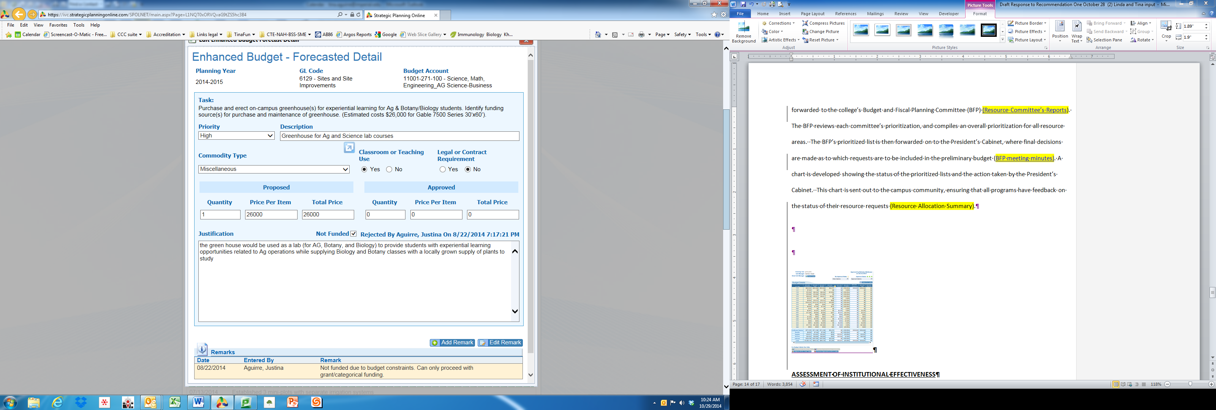

As SPOL implementation progresses and with anticipated upgrades to the software, this process will be further automated in 2016-2017. EMPC, resource plan committees, and the BFPC will evaluate the SPOL summary reports to determine if customization might improve reporting or decision-making throughout the process. Enhanced budget requests will continue to follow the established pathway for review, prioritization, budget action, and notification back to individual requesters.

Figure 7. SPOL Budget Detail Page (final action on budget request)

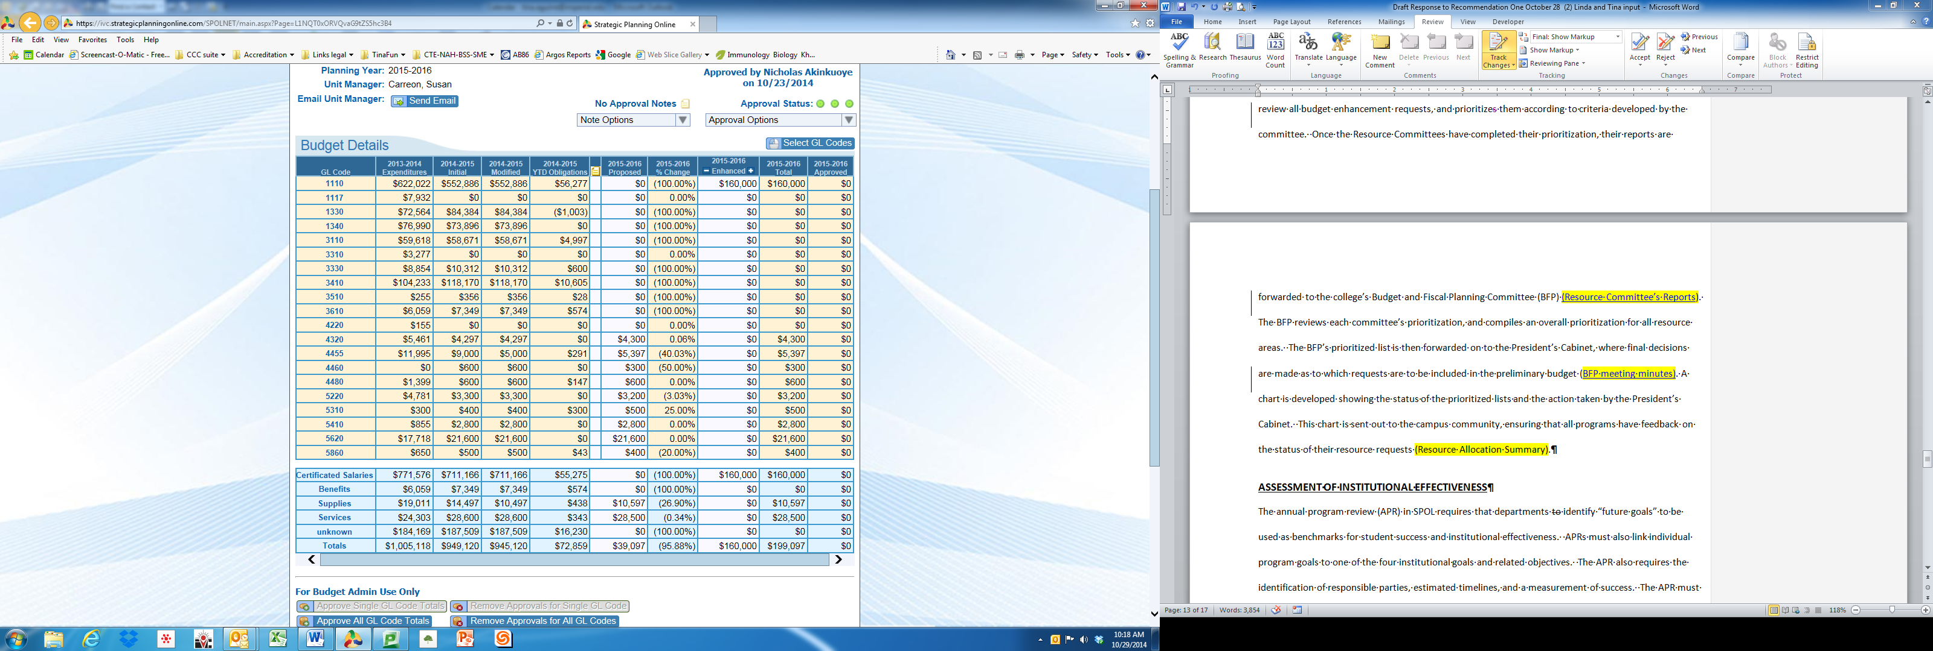

**ASSESSMENT OF INSTITUTIONAL EFFECTIVENESS**

**Goals and Objectives**

The Educational Master Planning Committee, at the May 2, 2014 meeting, began the process of assessing current institutional goals and objectives. The committee assigned the review to representatives from Academic Services, Student Services, Information Technology, Human Resources, Business Services, and the President’s Office. At the May 16, 2014 meeting, the current goals and objectives were affirmed to be carried on through the 2014-2015 year.[30]

Moving the Annual Program Review to SPOL required departments to identify “future goals” to be used as the department/program measure for student success or program effectiveness. The APR process in SPOL also required linking individual program goals to one of the four institutional goals or their objectives and one of the institutional priorities. Within the SPOL objectives further detail was required at the task level; i.e. assignment to a responsible party, target date of completion, and a measurement of success. The objectives also asked how the department/program objective would positively impact student success or institutional effectiveness (Figure 8).

Figure 8. SPOL Objective Detail (impact on student success or program effectiveness)

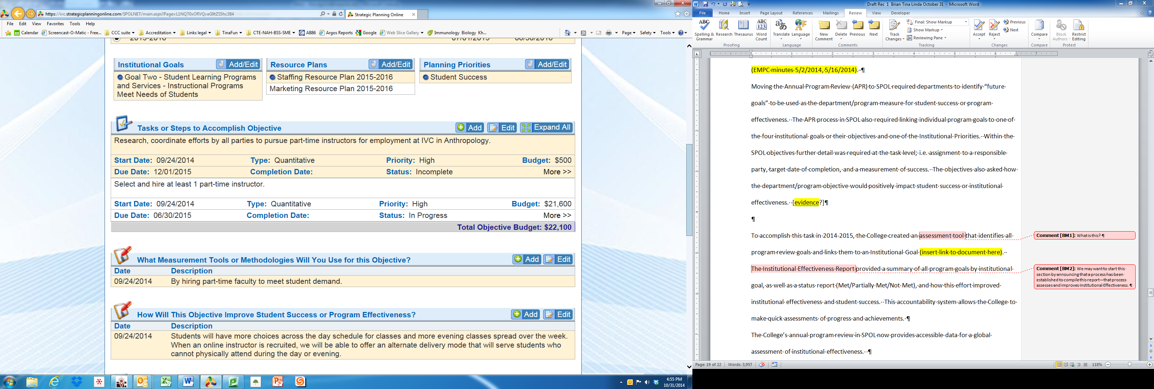

**Closing the Loop in Assessing Institutional Effectiveness**

The College revised the process to assess and report on institutional effectiveness in 2014-2015. An assessment tool was created that identifies all program review goals and links them to an institutional goal.[31] The Institutional Effectiveness Report provided a summary of all program goals by institutional goal, as well as a status report (Met/Partially Met/Not Met), and how this effort improved institutional effectiveness and student success. This accountability system allows the College to make quick assessments of progress and achievements.

The College’s annual program review in SPOL now provides accessible data for a global assessment of institutional effectiveness.

The EMPC, at the August 13, 2014 meeting, reviewed the Evaluation of Institutional Effectiveness tool, which consisted of a review of each objective from the 2013-2014 Program Review and the timeline for completion, responsible parties, and a statement of how the objective improves institutional effectiveness and student success.[32] The committee also reviewed the Budget Requests and Resource Allocation report, which included prioritization of resource requests by the resource plan committees, overall prioritization by the Budget and Fiscal Planning Committee, and final decisions on inclusion in the budget by the President’s Cabinet. The Evaluation of Institutional Effectiveness tool was returned to the programs as feedback on their Program Review objectives–feedback which could be used in the development of their 2014-2015 Program Reviews.[33]

The EMPC, at the May 16, 2014 meeting, conducted a review of the program review process for improvements in the process for the 2014-2015 Program Review. The results of a survey sent to all departments that completed program review were reviewed to assess the program review process and make recommendations for improvement. The results of the survey overwhelmingly documented the need to provide training in the SPOL system and interpretation of data. As a result, training sessions were scheduled over the summer and into the fall semester. Other recommendations included making sure that data are available when the semester begins in August, and to follow the timeline for completing program review by the end of the fall semester.[34] A summary of these assessments was compiled in an Educational Master Plan Progress Report that was presented to the Board of Trustees on August 20, 2014.[35] At this meeting, the Board took action to 1) approve the Educational Master Plan Progress Report, including the Assessment of Institutional Effectiveness and Resource Allocation; 2) reaffirm the 2013-2014 Institutional Goals for the 2014-2015 Program Review; 3) adopt the new academic and service area program review templates; 4) recommend faculty and staff training on the effective alignment of program goals with institutional goals; and 5) re-evaluate the College’s Mission Statement to ensure that the mission of the college aligns with the mission of California Community Colleges.[36]

To better clarify the linkage of institutional goals to program and operational goals, resource allocations, and the roles of various college plans, the EMPC adopted a revision to the Integrated Planning and Prioritization Model at the May 16, 2014 meeting.[37] The revised model, to take effect with the 2015-2016 year, shows the relationship between resource and planning committees, and the interrelationship between the various college plans and the Strategic Educational Master Plan. The Strategic Educational Master Plan will be a six-year plan with annual updates and progress reports, while other College plans may have different timeframes, depending on the nature of the plan and/or any regulatory requirements for the frequency of the particular plan. The Institutional Goals will be articulated in the Strategic Educational Master Plan, with the other plans aligning their goals with the Master Plan. The revised model also outlines the process for program review and resource allocation, including the role of the resource plan committees, Budget and Fiscal Planning Committee, President’s Cabinet, College Council, Academic Senate, and the Board of Trustees.[38]

**CONCLUSION**

Based on the External Evaluation Team’s acknowledgement of the College’s past improvements and the subsequent improvements evidenced in this report, the College is confident that it is in compliance with ACCJC’s accreditation standards and anticipates being restored to full accreditation status.

**RECOMMENDATION ONE EVIDENCE**

# RESPONSE TO RECOMMENDATION EIGHT

**Recommendation 8: In order to meet the standard, the team recommends the College develop a financial strategy that will result in balanced budgets that have ongoing revenues to meet or exceed its ongoing expenditures without the use of reserves; maintain the minimum prudent reserve level; and address funding for its long term financial commitments and its retiree health benefits costs. (III.D.1.a, III.D.3.a, and III.D.4, IV.B.1.c, IV.B.2.d.)**

**FINANCIAL STRATEGY**

**Permanent Budget Reductions**

The College is fully aware that effective management of budgets requires difficult decisions. To be successful in the future, the College must continue to structure its financial strategy so that the temporary, one-time measures used in the past such as furloughs, salary freezes, and retirement incentives will not be repeated as the sole means to address ongoing budget concerns.

The findings from the ACCJC External Evaluation Team and Financial Reviewer Panel both indicate the need for Imperial Valley College to address “Issues related to the collective bargaining contract with classified employees”– insisting that action be taken to resolve this issue in this Follow-Up Report.[39] Such action has occurred. The College has moved forward with the fact-finding process with the College’s classified employees, which are part of the California School Employees Association. Following this fact-finding process at a special board meeting in August 2014, the Board of Trustees voted to implement the Last, Best, and Final Offer presented in 2013 (Figure 9).[40] The result of this extensive process was a revised salary schedule that results in immediate cost savings, and is financially sustainable. One element that would provide additional salary savings would be retirements, which are not used in this projection because estimating retirements is difficult to predict.

Figure 9. District’s Last, Best Final Offer (LBFO) Compared to Previous Contract with CSEA.

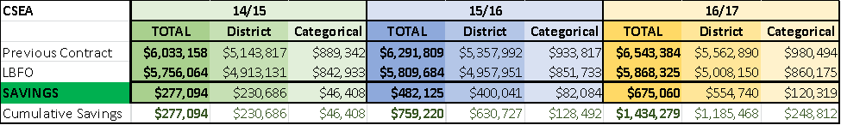

This adjustment allows for the overall percentage of the General Fund covering salary and benefits to be at a sustainable level, which results in a growing reserve (Figure 10).[41] [42] [43] [44] [45] [46] [47] [48] [49] [50] [51] [52]

Figure 10. Revised Budget Projection Including Estimated Impact of Labor Negotiations

|  |  |  |  |
| --- | --- | --- | --- |
|  | **2014-15** | **2015-16** | **2016-17** |
| REVENUE | 36,651,558 | 37,221,558 | 37,821,558 |
| EXPENSE |  |  |  |
| Salaries | 23,298,776 | 23,530,844 | 23,623,199 |
| Benefits | 8,898,003 | 9,060,559 | 9,260,909 |
| Operational Costs | 3,447,610 | 3,447,610 | 3,447,610 |
| Capital Equipment | 71,030 | 71,030 | 71,030 |
| Debt Retirement | 1,100,508 | 425,000 | 425,000 |
| Total Expense | 36,815,527 | 36,535,043 | 36,827,748 |
| Surplus/deficit | -164,369 | 686,515 | 993,810 |
| Beginning Reserve | 2,473,273 | 2,308,904 | 2,995,419 |
| Ending Reserve | 2,308,904 | 2,995,419 | 3,989,229 |
| % of Unrestricted Gen Fund | 6.27% | 8.20% | 10.83% |

In addition to savings from the salary adjustments, the College has implemented significant cost-containment measures. The College has reduced service in its Custodial and Grounds departments. Although the district has added two new buildings, covering approximately 62,000 additional square feet, it has not increased the size of its custodial staff. In the future, as the College finances improve, custodial services will be restored with the addition of new hires.

The College’s building construction and renovation program also works to contain costs. All of the new buildings on campus were built to LEED (Leadership in Energy and Environmental Design) Standards. Building 2700 has been certified as LEED Silver and the two newest buildings are still undergoing the LEED certification process. Additionally, all of our building renovation projects are built to meet LEED certification. This concentration on efficiency has led to a significant reduction in energy costs on campus (Figure 11).

Figure 11. Energy Efficiency

|  |  |  |  |  |
| --- | --- | --- | --- | --- |
|  | **District:** | Imperial Community College District | | |
|  | **College:** | Imperial Valley College | |  |
| **Fiscal Year** | **Annual Electricity KWH Usage** | **Electricity to BTU Conversion** | **Average BTUs Per GSF Per Week** | | **Percent Reduction of Baseline Year** |
| 2011-2012 | 4,483,200 | 15,301,161,600 | 1253 | | -16.59% |
| 2012-2013 | 3,609,600 | 12,319,564,800 | 963 | | -35.90% |
| 2013-2014 | 2,979,200 | 10,168,009,600 | 901 | | -40.04% |

This increase in energy efficiency has reduced our annual combined electrical and natural gas usage from an annual average of 1502 BTU’s per Gross Square Foot (GSF) per week in fiscal year 2001-02 to 901 BTU per GSF per week in fiscal year 2013-2014. This is a 40.04% reduction in energy use.[53]

**FCMAT**

In the report of the External Evaluation Team dated May 6, 2014, the visiting team acknowledged that the College “is clearly taking steps towards compliance…It has implemented some of the 72 recommendations from the 2012 FCMAT report”.[54] The College continues to make significantprogress analyzing and implementing the applicable recommendations made in the 2012 FCMAT report through the development of detailed action plans. These action plans identify the party responsible, map out the steps needed to fulfill this recommendation, and provide a projected timeline for full implementation of the recommendation in question. The Superintendent/President, the President’s Cabinet, and the Board of Trustees will apply the action plans as deemed appropriate.[55]

**LINKING INSTITUTIONAL GOALS WITH RESOURCE ALLOCATION**

*I.B.3. The institution assesses progress towards achieving its stated goals and makes decisions regarding the improvement of institutional effectiveness in an ongoing and systematic cycle of evaluation, integrated planning, resource allocation, implementation, and re-evaluation. Evaluation is based on analyses of both quantitative and qualitative data.*

*III.D.1.a: Financial planning is integrated with and supports all institutional planning.*

*III.D.4: Financial resource planning is integrated with institutional planning. The institution systematically assesses the effective use of financial resources and uses the results of the evaluation as a basis for improvement of the institution.*

The College understands that collaboration is crucial to sustainable program quality improvement, and that financial resource planning must be integrated with institutional planning to provide a reasonable expectation of the College’s short-term and long-term financial projections. The College has established integrated planning processes and data mining infrastructure that supports sustainable program review and enrollment management.

The complete implementation of Strategic Planning Online (SPOL) combined with the College’s Enrollment Management Plan allow for distribution of resources to support the development, maintenance, and enhancement of the College’s programs and services.[56] [57] SPOL allows for additional or new funding requests to appear in the enhanced column during the program review process.[58] Enhanced budget requests are associated with the appropriate account and general ledger codes prior to preliminary approvals and prioritization by the resource plan committees, the Budget and Fiscal Planning Committee, and the President’s Cabinet. Although not all enhanced requests were or can be funded by the College, this process affords each program the opportunity to review its goals and request funds that would be needed to achieve those goals–thus connecting planning to budget requests. This process also illuminates how enhanced budget requests obligate the College to generate new revenue, increase cost efficiencies, and tie the budget to the institutional goals and mission.[59]

**FINANCIAL FORECASTING AND ENROLLMENT MANAGEMENT**

The College has completed a full cycle under the tentative Enrollment Management Plan (Administrative Procedure AP 3260), including the evaluation of the effectiveness of the plan to achieve the College’s enrollment and FTES targets with the development of the Enrollment Management Rubric.[60] [61] Below is an excerpt from the stated rubric, reflecting benchmark two:

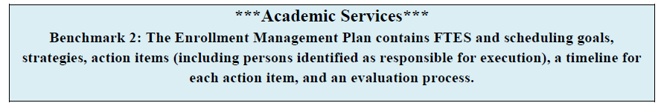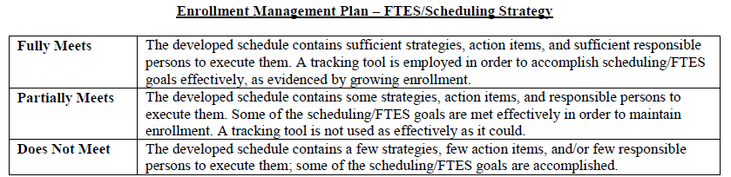

The Enrollment Management Rubric was distributed to all members of the Enrollment Management Task Force in May of 2014 to ensure broad participation. Feedback was collected from the College’s diverse constituencies.[62] The results of this evaluation were used to perfect the draft of the Enrollment Management Plan, so that it was ready to send through the shared governance process in the fall of 2014 as an official administrative procedure.[63] The College will continue to improve the College’s enrollment management processes by ensuring the College’s mission and goals are the foundation for financial planning through this comprehensive evaluation process.[64] Below is an excerpt from the rubric results, reflecting the analysis of benchmark two (Figure 12).

Figure 12. Enrollment Management Rubric Analysis

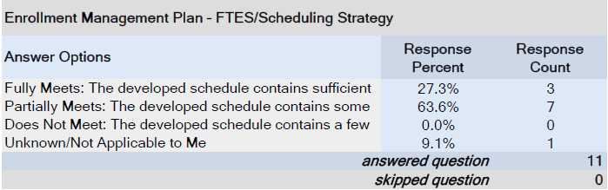

These evaluations provide documentation that the Enrollment Management Plan has been successfully implemented and that it assures systematic review of the planning and decision-making processes.[65]

A multi-year budget projection has allowed the College to determine how existing budget transactions impact the College’s overall operating budget while affording sufficient time to develop and initiate a plan to address any untoward impact.[66] [67] Since the College has chosen to project a conservative 1% growth factor, after fiscal year 2014-2015, the expense side of the budget will need to be well-controlled so that a balanced budget continues to be attainable. In the future, the College’s fiscal planning must consider the ongoing cost increases in its financial projections (including step/column increases, benefit cost increases, infrastructure/utility expenses, and health benefits for both retirees and active employees). Projecting overly optimistic estimates of state economics coupled with overly aggressive estimates of enrollment can expose the College to an unhealthy level of risk. Instead, the College has chosen to complete financial forecasting with realistic budget assumptions and a conservative approach to projecting FTES revenue, including growth.

The present forecasting provides the means for the College to express its goals and priorities and to ensure internal consistency. This process allowed the College to realize not only full restoration, but 1% growth in fiscal year 2013-2014.[68] With the reinstatement of the Winter Intersession in 2015, the College is confident that growth will continue to be achieved in both 2015-2016 and 2016-2017, as reflected in the College’s multi-year budget projection.

The level of growth projected for the next three years indicates that it is possible to keep the operational costs flat with the exception of inflation (and inflation is relatively flat).

The College’s revenue and cost projections use the following assumptions to formulate its budget forecasts:

Revenue for the next three years will be relatively flat, with anticipated growth of 2.75% in fiscal year 2014-2015, and 1% in fiscal years 2015-2016, 2016-17, and 2017-2018.

Cost of Living Adjustments (COLA) are anticipated to be 0.85% in 2014-2015, 1% in both 2015-2016 and 2016-2017.

Salary projections are based on current labor agreements with both bargaining units and unrepresented groups.

Benefits include increases for health insurance (7% annually) and PERS and STRS inflators (as indicated by the pension providers).

Staffing levels are projected to be stable for the next three years.

Costs other than salaries and benefits (operational costs) are not projected to undergo significant growth due to our conservative FTE growth projections (take up 1% for 2017-2018

Debt payments after 2015-2016 are the lease revenue bond and TRANS interest.

The Certificate of Participation Bond (COP) will be paid off July 18, 2014.

The 2014-2015 projected deficit is due to a final one-time balloon payment of the COP Bond ($742,000).

California State Unemployment remains low (Figure 13).

Figure 13. California Economic Forecast

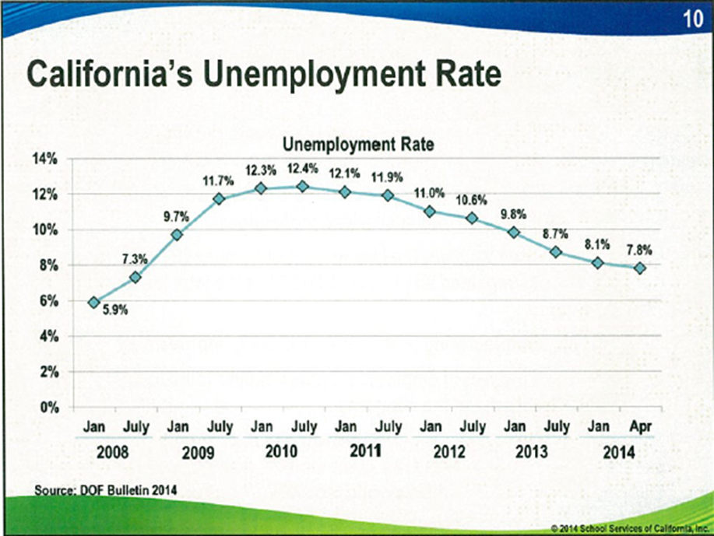

The State of California continues to signal a healthy financial outlook that solidifies the College’s position to project growth conservatively (Figure 14). The Governor’s 2014-2015 Budget Summary reflects an increase of 11.4% in state funding for California Community Colleges, with continued growth projected “significantly over the next several years as Proposition 98 resources continue to rebound.[69] The College has planned for 2.75% growth in fiscal year 2014-2015, with the option to claim additional apportionment due to the recent announcement from the Chancellor’s Office to restore Colleges to 2011-2012 FTES figures.[70]

Figure 14. California Anticipated Revenue Growth

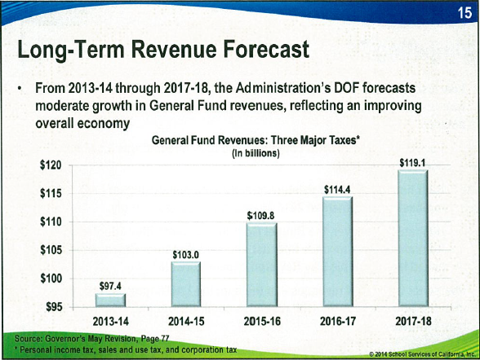

The availability and use of data in the planning processes at the College has increased substantially. Additional data sources have been developed to inform the College’s budget allocation, planning, and decision making processes.[71] The Academic Services Office and the Business Services Office, in a joint effort, regularly review updated enrollment projections to determine if adjustments to future semester course scheduling and instructional salary accounts are warranted. Below is the Academic Services FTES Projection document as of August 6,2014, prior to the start of the fall 2014 semester, and as of census day September 15, 2014 (Figure 15 and Figure 16). These projections allow the College to closely manage its enrollment and plan accordingly.

Figure 15. August 6, 2014, FTES Projection

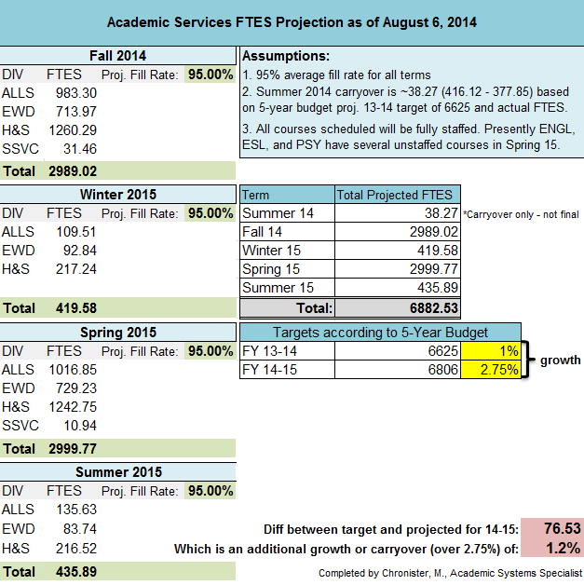

Figure 16. September 15, 2014, FTES Projection

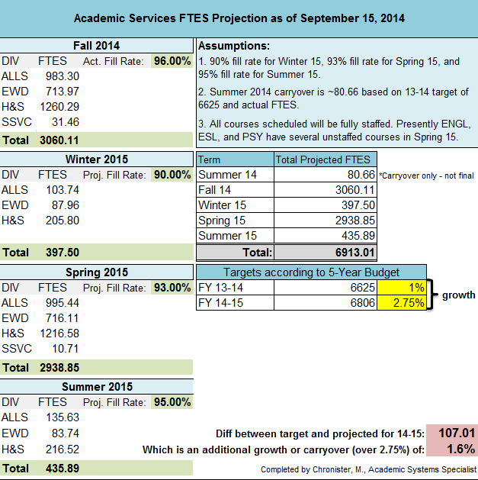

The College’s projection of FTES revenue will be viewed as a trend based on the labeled assumptions as reflected in the tables above rather than as a prediction of exact numbers. The College believes that its projection is reasonable based on its review of all available relevant data.

**BALANCED BUDGET**

*III.D.3.a: The institution has sufficient cash flow and reserves to maintain stability, strategies for appropriate risk management, and develops contingency plans to meet financial emergencies and unforeseen occurrences.*

For 2013-2014, the College can certify that it did not use reserves to balance the ongoing operational budget.[72] Ongoing revenues were used to meet ongoing expenditures as required. The College understands that reserves are in place to be used for one-time transactions if necessary, and remains compliant with this requirement. The General Fund reserve remained above the Board designated 5% minimum. For 2014-2015, the College has adopted a balanced budget that refrains from using its General Fund reserves,requiring that ongoing revenues continue to meet ongoing expenditures.[73] The multi-year budget projection indicates that the College’s reserves will continue to be at 5% or greater now and in the years to come.[74]

**LONG-TERM FINANCIAL COMMITMENTS AND RETIREE HEALTH BENEFIT COSTS (OPEB)**

The College currently spends an average of approximately $1.1 million dollars as an annual pay-as-you-go payment to address the long term other post-employment benefit costs (OPEB).[75] Additionally, the Budget and Fiscal Planning Committee voted to recommend that 30% of the favorable variance at the close of the fiscal year (between budget and actual) be dedicated to start paying down this liability.[76] Unfortunately, there was not a favorable variance in the 2013-2014 year.

The College understands that this method alone will not adequately fund the liability at a sufficient pace to keep up with the College’s projected future liability as revealed in the College’s Actuary Study conducted by Total Compensations Systems Inc.[77] Because of this, the College has undertaken the task to identify cost containment measures as well as refine the College’s long-term plan, in order for the College to maximize returns on its investments, with minimal risk, as a means to grow the OPEB fund and lower the College’s liability. At the request of the Budget and Fiscal Planning Committee, a financial advisor from Backstrom, McCarley, Berry & Co. gave a presentation defining the OPEB liability and offering possible options the College may want to consider to address it.[78] Based on the information provided, the College has decided to continue utilizing the pay-as-you-go method to address this liability to allow for adequate time to develop a strategic long-term plan, including the establishment of an irrevocable trust and investment policy with assistance from a qualified and experienced financial advisor.

On August 1, 2017, the College will have paid off a Lease Revenue Bond that has as an annual debt service of approximately $310,000.[79] The retirement of this debt service affords the College an opportunity to address this liability without further encroachment of precious General Fund dollars, as it will have the opportunity to simply redirect these funds to the irrevocable trust established to help fund the OPEB liability, or to procure an OPEB bond to address this liability, based on the direction given by the financial advisor. If a bond is obtained, the annual debt service will be paid out of the General Fund to maximize the accumulation of the irrevocable trust while also protecting the College’s General Fund from unanticipated exposure to possible volatile market conditions. In addition to this investment, the College will also redirect the approximate $1.1 million that the College has been paying under the pay-as-you-go method, along with any investment earnings, to the irrevocable trust. Finally, the College will deposit 30% of the favorable variance at the close of the fiscal year as explained above. The trust will then be used to cover the annual post-employment benefit expenses as needed.[80] [81] [82] [83] The College will be vetting each option’s impact on financial efficiency and probable implementation timelines to both the participatory governance committees and the Board of Trustees. Below is a bulleted recap of the timeline of events planned (Figure 17).

Figure 17. OPEB Timeline of Events

|  |
| --- |
| **October 2014:** Presentation given by financial advisor from Backstrom, McCarley, Berry & Co. |
| **2015-2016:** Discuss cost containment and pre-funding measures related to managing the liability beyond the existing pay-as-you go method. |
| **2016-2017**: Review and finalize the College’s plan to fully manage the OPEB liability |
| **2017:** Create the irrevocable trust and investment policy |
| **2017:** Redirect the annual debt service of $310,000 to the irrevocable trust established or uses the $310,000 to procure a bond based on the direction given by the financial advisor. If a bond is obtained, the annual debt service will be paid out of the General Fund. |
| **2017:** Redirect the ~$1.1 million presently used to fund the pay-as-you-go method to the irrevocable trust. |
| **2017:** Utilize irrevocable trust as needed to cover post-employment benefit expenses. |

The College understands that strategic, in-depth planning is imperative to financial stability in achieving both its short-term and long-term goals. Therefore, decisions related to long-term commitments will not be made in haste. The College will continue to utilize the pay-as-you-go method coupled with the positive variance contributions as outlined above to fund this liability in the short-term, while a long-term, sufficient and sound funding method is researched, developed, and finalized. Ultimately, the College’s goal is to address the debt associated with the OPEB liability and have it funded within a reasonable time. The College understands that this plan as stated will have the added benefit of relieving pressure on the General Fund in the future.

**CATEGORICAL PROGRAMS**

In its letter to the College dated February 2014, the Financial Reviewer Panel expressed concern with the College’s use of unrestricted General Fund monies to make up for shortfalls in the Child Development Center Fund, as well as other categorical programs. Specifically, the letter states that “the college paid or subsidized the programs by augmenting them with funds to pay all costs incurred…taking a priority status that has not been discussed”.[84] Since this disclosure, the College’s Board of Trustees has requested a detailed analysis be conducted and presented pertaining to the programs in question to ensure proper allocation of resources occurs. A Board Retreat was held on August6, 2014, which included a presentation of the new funding structure for the Disabled Students Programs and Services.[85] This new funding model reflects less demand of unrestricted General Fund monies while still maintaining these valuable services at the levels needed to serve this population. The Board expressed overwhelming support and praise to the Dean of Counseling for his effort in addressing this concern without reducing the services offered and supported the augmented funding model.

Similarly, at the October 15, 2014 special board meeting, the CBO made a presentation of the number of indirect benefits the College receives as a result of the College’s investment of unrestricted General Fund dollars. Below is a chart of General Fund dollars being used to subsidize categorical programs as presented at the October 15, 2014 board meeting (Figure 18).

Figure 18. Categorical Program Subsidies

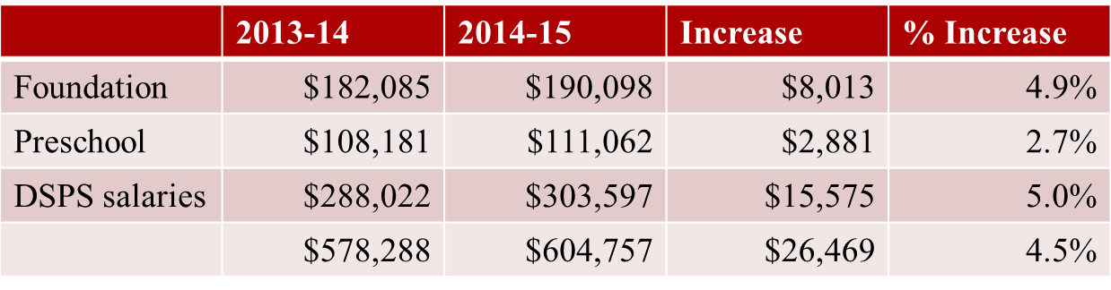

Based on the information provided, the Board of Trustees provided direction to the Superintendent/President and the Chief Business Officer to continue to fund the categorical programs in question, including the Child Development Center, the Foundation, and the Disabled Students Programs and Services, at the present funding levels. Subsequently at the October 15, 2014 Board Meeting, the Chief Business Officer requested the Board to direct the President to establish a task force to review the current model and make recommendations, if needed, to revise the structure currently in place.[86]

The College continues to analyze all of its programs, including those that receive categorical and/or special program funding, to ensure that they operate efficiently and effectively. Concurrently, before taking action on program requests to increase unrestricted General Fund allocations, public discussions will take place to review 1) the connection the program or service has with the College’s mission, 2) the priority the program or service has compared to other enhanced financial requests, and 3) the financial impact the program or service would have on existing and future budgets.

Under the new program review timeline,[87] evaluation of the current year’s budget falls early in the spring semester. This affords additional time for the Budget and Fiscal Planning Committee to evaluate the budget process following the entire program review cycle to answer the following questions:

* Did the College address the unmet needs?
* Did this process lead to a balanced budget?
* Was there a timely feedback process?
* Was it easy to assign and track responsibility?
* Was spending tied to the mission?

**Superintendent/President and Board Involvement and Control of Budgetary Processes**

*IV.B.1.c: The governing board has ultimate responsibility for educational quality, legal matters, and financial integrity.*

*IV.B.2.d: The president effectively controls budget and expenditures.*

The Superintendent/President held a town hall meeting shortly after the April 2014 visit by the External Evaluation Team to discuss the anticipated accreditation status of the College. The town hall meeting was open to the Board of Trustee members, administrators, faculty, and staff, and the Board President himself was in attendance. The meeting included discussion of the serious financial and planning issues facing the College and the need to take drastic measures to resolve these issues and balance the budget so that ongoing revenues continue to meet ongoing expenses.[88] This demonstrates that both the Superintendent/President and the Board of Trustees are committed to maintaining the financial stability of the institution.

The Superintendent/President continues to receive updates on the College’s budgetary process in the weekly scheduled President’s Cabinet meetings. These meetings are attended by the College’s senior executive members, which include the Vice President for Business Services (CBO), Vice President for Academic Services (CIO/ALO), Vice President for Information Technology, Student Services, and Research (CTO/CSSO), and the Chief Human Resources Officer (CHRO). Since these meetings contain conversations that are confidential in nature, minutes are not kept. However, agendas are developed and documented to confirm discussion has taken place on key issues. Two specific agendas are cited as evidence in this report to confirm the Superintendent/President has been involved and continues to provide direction as needed on important budgetary issues.[89] [90]

In addition, as evidence that the Board of Trustees recognizes its responsibility under Standard IV.B.1.c, , following the conclusion of negotiations with CSEA, Board President Karla Sigmond reached out to the campus community in a letter dated Friday September 5, 2014, to explain that the difficult financial decisions made by the Board this year were not made lightly.  She stated, “This College is greater than any one group or individual, and we all must take actions that benefit the long term needs of the College…we simply do not have any choice but to adjust our expenses to fit our available income.” [91]

**CONCLUSION**

The External Evaluation Team Report of April 2014 recommended “that the College accelerate its efforts and, if necessary, take drastic steps to come into full compliance in the next year”.[92] The College believes that the steps explained in this response are indeed substantial and effective, allowing the College to meet both the Standards set by the Accrediting Commission for Community and Junior Colleges and the goals the College has set for itself. The processes described above confirm that the Commission’s recommendation to develop a financial strategy that results in balanced budgets, maintain minimum prudent reserve levels, and address long-term financial commitments including other post-employment benefits cost, has been fully addressed by the College.

**RECOMMENDATION EIGHT EVIDENCE**

1. [RP 1.01 Email to Campus Community, Forum, 5-14-14](http://accreditation.imperial.edu/docs/2015/follow-up-report/Report%20Preparation/RP%201.01%20Email%20to%20Campus%20Community,%20Forum,%205-14-14,%205-15-14.pdf)
2. [RP 1.02 Email to CART Executive Team, Preliminary Timeline, 5-30-14](http://accreditation.imperial.edu/docs/2015/follow-up-report/Report%20Preparation/RP%201.02%20Email%20to%20CART%20Executive%20Team,%20Preliminary%20Timeline,%205-30-14.pdf)
3. [RP 1.03 Letter from ACCJC, Accreditation Status, 7-3-14](http://accreditation.imperial.edu/docs/2015/follow-up-report/Report%20Preparation/RP%201.03%20Letter%20from%20ACCJC,%20Accreditation%20Status,%207-3-14.pdf)
4. [RP 1.04 Email to Follow-Up Report Writing Teams, Reinstatement and Updated Timeline, 7-9-14](http://accreditation.imperial.edu/docs/2015/follow-up-report/Report%20Preparation/RP%201.04%20Email%20to%20Follow-Up%20Report%20Teams,%20Reinstatement%20and%20Updated%20Timeline,%207-9-14.pdf)
5. [RP 1.05 CART Meeting Minutes](http://accreditation.imperial.edu/docs/2015/follow-up-report/Report%20Preparation/RP%201.05%20CART%20Meeting%20Minutes.pdf)
6. [RP 1.06 Academic Senate and College Council Meeting Minutes](http://accreditation.imperial.edu/docs/2015/follow-up-report/Report%20Preparation/RP%201.06%20Academic%20Senate%20and%20College%20Council%20Meeting%20Minutes.pdf)
7. [RP 1.07 Academic Senate Agenda and Minutes 12-10-14](http://accreditation.imperial.edu/docs/2015/follow-up-report/Report%20Preparation/RP%201.07%20Academic%20Senate%20Agenda%20and%20Minutes%2012-10-14.pdf)
8. [RP 1.08 College Council Minutes 1-5-15](http://accreditation.imperial.edu/docs/2015/follow-up-report/Report%20Preparation/RP%201.08%20College%20Council%20Minutes,%2001-05-15.pdf)
9. [RP 1.09 Memo from President to ALO and CART Co-Chairs, 1-6-15](http://accreditation.imperial.edu/docs/2015/follow-up-report/Report%20Preparation/RP%201.09%20Memo%20from%20President%20to%20ALO%20and%20CART%20Co-Chairs,%2001-06-15.pdf)
10. [RP 1.10 Board of Trustees Minutes 1-21-15, Resolution No. 16295](http://accreditation.imperial.edu/docs/2015/follow-up-report/Report%20Preparation/RP%201.10%20Board%20Minutes,%20Resolution%2016295,%2001-21-15.pdf)
11. [REC.1.01 Letters from ACCJC 5-6-14 and 7-3-14](http://accreditation.imperial.edu/docs/2015/follow-up-report/Response%20to%20Recommendation%201/REC.1.01%20Letters%20-%20ACCJC%20dated%20May%206%20and%20July%203,%202014.pdf)
12. [REC.1.02 AP 3260 Enrollment Management Plan](http://accreditation.imperial.edu/docs/2015/follow-up-report/Response%20to%20Recommendation%201/REC.1.02%20AP%203260%20Enrollment%20Management%20Plan.pdf)
13. [REC.1.03 Sample Committee Self-Evaluation](http://accreditation.imperial.edu/docs/2015/follow-up-report/Response%20to%20Recommendation%201/REC.1.03%20Sample%20Committee%20Self%20Evaluation%20Form.pdf)
14. [REC.1.04 CART Bylaws; CART Minutes 11-4-14](http://accreditation.imperial.edu/docs/2015/follow-up-report/Response%20to%20Recommendation%201/REC.1.04%20Revised%20CART%20Bylaws%3b%20Cart%20Minutes%20dated%2011-4-14.pdf)
15. [REC.1.05 EMPC Bylaws; EMPC Minutes 12-5-14](http://accreditation.imperial.edu/docs/2015/follow-up-report/Response%20to%20Recommendation%201/REC.1.05%20Revised%20EMPC%20Bylaws%3b%20EMPC%20Minutes%2012-5-14.pdf)
16. [REC.1.06 Summary Evaluation of Academic Senate Sub-Committee Self Evaluations](http://accreditation.imperial.edu/docs/2015/follow-up-report/Response%20to%20Recommendation%201/REC.1.06%20Summary%20Evaluation%20for%20Committees.pdf)
17. [REC.1.07 Academic Senate Minutes 8-20-14, 9-3-14; College Council Minutes 9-22-14](http://accreditation.imperial.edu/docs/2015/follow-up-report/Response%20to%20Recommendation%201/REC.1.07%20Academic%20Senate%20Minutes%208-20-14,%209-3-14%3b%20College%20Council%20Minutes%209-22-14.pdf)
18. [REC.1.08 Academic Senate Minutes 9-17-14; College Council Minutes 9-8-14](http://accreditation.imperial.edu/docs/2015/follow-up-report/Response%20to%20Recommendation%201/REC.1.08%20Academic%20Senate%20Minutes%209-17-14%3b%20College%20Council%20Minutes%209-8-14.pdf)
19. [REC.1.09 EMPC Bylaws; CART Bylaws](http://accreditation.imperial.edu/docs/2015/follow-up-report/Response%20to%20Recommendation%201/REC.1.09%20Revised%20EMPC%20Bylaws%3b%20Revised%20CART%20Bylaws.pdf)
20. [REC.1.10 Planning Calendars 2013-2014; Planning Calendar 2014-2015](http://accreditation.imperial.edu/docs/2015/follow-up-report/Response%20to%20Recommendation%201/REC.1.10%20Planning%20Calendar%202013-2014%3b%20Planning%20Calendar%202014-2015.pdf)
21. [REC.1.11 ACCJC Report of External Evaluation Team 5-6-14](http://accreditation.imperial.edu/docs/2015/follow-up-report/Response%20to%20Recommendation%201/REC.1.11%20External%20Evaluation%20Team%20Report%205-6-14.pdf)
22. [REC.1.12 2013-2014 Academic Program Review Template](http://accreditation.imperial.edu/docs/2015/follow-up-report/Response%20to%20Recommendation%201/REC.1.12%202013-2014%20Academic%20Program%20Review%20Template.pdf)
23. [REC.1.13 2014-2015 Academic Program Review Template](http://accreditation.imperial.edu/docs/2015/follow-up-report/Response%20to%20Recommendation%201/REC.1.13%202014-2015%20Academic%20%20Program%20Review%20Template.pdf)
24. [REC.1.14 2014-2015 Service Area Program Review Template](http://accreditation.imperial.edu/docs/2015/follow-up-report/Response%20to%20Recommendation%201/REC.1.14%202014-2015%20Service%20Area%20Program%20Review%20Template.pdf)
25. [REC.1.15 2014-2015 Program Review Handbook](http://accreditation.imperial.edu/docs/2015/follow-up-report/Response%20to%20Recommendation%201/REC.1.15%202014-2015%20EMPC%20Program%20Review%20Handbook.pdf)
26. [REC.1.16 Educational Master Planning Committee Minutes 10-10-14](http://accreditation.imperial.edu/docs/2015/follow-up-report/Response%20to%20Recommendation%201/REC.1.16%20Educational%20Master%20Planning%20Committee%20Minutes%2010-10-14.pdf)
27. [REC.1.17 Resource Plan Committees Reports](http://accreditation.imperial.edu/docs/2015/follow-up-report/Response%20to%20Recommendation%201/REC.1.17%20Resource%20Committees%20Reports.pdf)
28. [REC.1.18 Budget & Fiscal Planning Minutes 6-9-14](http://accreditation.imperial.edu/docs/2015/follow-up-report/Response%20to%20Recommendation%201/REC.1.18%20Budget%20&%20Fiscal%20Planning%20Minutes%206-9-14.pdf)
29. [REC.1.19 Resource Allocation Summary](http://accreditation.imperial.edu/docs/2015/follow-up-report/Response%20to%20Recommendation%201/REC.1.19%20Resource%20Allocation%20Summary.pdf)
30. [REC.1.20 Educational Master Planning Committee Minutes 5-2-14, 5-15-14](http://accreditation.imperial.edu/docs/2015/follow-up-report/Response%20to%20Recommendation%201/REC.1.20%20Educational%20Master%20Planning%20Committee%20Minutes%205-2-14,%205-16-14.pdf)
31. [REC.1.21 Evaluation of Institutional Effectiveness and Resource Allocation](http://accreditation.imperial.edu/docs/2015/follow-up-report/Response%20to%20Recommendation%201/REC.1.21%20Evaluation%20of%20Institutional%20Effectiveness%20and%20Resource%20Allocation%20-%20Academic%20Services%20and%20SSTR.pdf)
32. [REC.1.22 Educational Master Planning Committee Minutes 8-13-14](http://accreditation.imperial.edu/docs/2015/follow-up-report/Response%20to%20Recommendation%201/REC.1.22%20Educational%20Master%20Planning%20Committee%20Minutes%208-13-14.pdf)
33. [REC.1.23 Evaluation of Institutional Effectiveness and Resource Allocation](http://accreditation.imperial.edu/docs/2015/follow-up-report/Response%20to%20Recommendation%201/REC.1.23%20Evaluation%20of%20Institutional%20Effectiveness%20and%20Resource%20Allocation%20-%20Academic%20Services%20and%20SSTR.pdf)
34. [REC.1.24 Educational Master Planning Committee Minutes 5-16-14, Survey](http://accreditation.imperial.edu/docs/2015/follow-up-report/Response%20to%20Recommendation%201/REC.1.24%20Educational%20Master%20Planning%20Committee%20Minutes%205-16-14,%20Survey.pdf)
35. [REC.1.25 Educational Master Plan Progress Report](http://accreditation.imperial.edu/docs/2015/follow-up-report/Response%20to%20Recommendation%201/REC.1.25%202013-2014%20Educational%20Master%20Plan%20Progress%20Report,%20Executive%20Summary.pdf)
36. [REC.1.26 Board of Trustees Minutes 8-20-14, Resolution No. 16141](http://accreditation.imperial.edu/docs/2015/follow-up-report/Response%20to%20Recommendation%201/REC.1.26%20Board%20Minutes%208-20-14,%20Resolution%20No.%2016141.pdf)
37. [REC.1.27 Educational Master Planning Committee Minutes 5-16-14](http://accreditation.imperial.edu/docs/2015/follow-up-report/Response%20to%20Recommendation%201/REC.1.27%20Educational%20Master%20Planning%20Committee%20Minutes%205-16-14.pdf)
38. [REC.1.28 Integrated Planning and Prioritization Model](http://accreditation.imperial.edu/docs/2015/follow-up-report/Response%20to%20Recommendation%201/REC.1.28%20Integrated%20Planning%20and%20Prioritization%20Model.pdf)
39. [REC.8.01 ACCJC Action Letter 7-3-14](http://accreditation.imperial.edu/docs/2015/follow-up-report/Response%20to%20Recommendation%208/REC.8.01%20ACCJC%20action%20letter%207-3-14.pdf)
40. [REC.8.02 Resolution 16168 CSEA Last, Best and Final Offer Implementation 8-28-14](http://accreditation.imperial.edu/docs/2015/follow-up-report/Response%20to%20Recommendation%208/REC.8.02%20Resolution%2016168%20CSEA%20last%20best%20and%20final%20offer%20implementation%2008-28-14.pdf)
41. [REC.8.03 Classified Salary Schedule 2011-2012](http://accreditation.imperial.edu/docs/2015/follow-up-report/Response%20to%20Recommendation%208/REC.8.03%20Classified%20Salary%20Schedule%202011-12.pdf)
42. [REC.8.04 Classified Salary Schedule 2013-2014](http://accreditation.imperial.edu/docs/2015/follow-up-report/Response%20to%20Recommendation%208/REC.8.04%20Classified%20Salary%20Schedule%202013-14.pdf)
43. [REC.8.05 Administrator Salary Schedule 2012-2013](http://accreditation.imperial.edu/docs/2015/follow-up-report/Response%20to%20Recommendation%208/REC.8.05%20Administrator%20Salary%20Schedule%202012-13.pdf)
44. [REC.8.06 Administrator Salary Schedule 2013-2015](http://accreditation.imperial.edu/docs/2015/follow-up-report/Response%20to%20Recommendation%208/REC.8.06%20Administrator%20salary%20schedule%202013-15.pdf)
45. [REC.8.07 Classified Management Salary Schedule 2012-2013](http://accreditation.imperial.edu/docs/2015/follow-up-report/Response%20to%20Recommendation%208/REC.8.07%20Classified%20Management%20salary%20schedule%202012-13.pdf)
46. [REC.8.08 Classified Management Salary Schedule 2013-2015](http://accreditation.imperial.edu/docs/2015/follow-up-report/Response%20to%20Recommendation%208/REC.8.08%20Classified%20Management%20salary%20schedule%202013-15.pdf)
47. [REC.8.09 Confidential Salary Schedule 2012-2013](http://accreditation.imperial.edu/docs/2015/follow-up-report/Response%20to%20Recommendation%208/REC.8.09%20Confidential%20salary%20schedule%202012-13.pdf)
48. [REC.8.10 Confidential Salary Schedule 2013-2015](http://accreditation.imperial.edu/docs/2015/follow-up-report/Response%20to%20Recommendation%208/REC.8.10%20Confidential%20salary%20schedule%202013-15.pdf)
49. [REC.8.11 Faculty Salary Schedule 2012-2013, 177 days](http://accreditation.imperial.edu/docs/2015/follow-up-report/Response%20to%20Recommendation%208/REC.8.11%20Faculty%20Salary%20Schedule%202012-13%20177%20days.pdf)
50. [REC.8.12 Faculty Salary Schedule 2013-2015, 177 days](http://accreditation.imperial.edu/docs/2015/follow-up-report/Response%20to%20Recommendation%208/REC.8.12%20Faculty%20Salary%20Schedule%202013-15%20177%20day.pdf)
51. [REC.8.13 Faculty Salary Schedule 2012-2013, 199 days](http://accreditation.imperial.edu/docs/2015/follow-up-report/Response%20to%20Recommendation%208/REC.8.13%20Faculty%20Salary%20Schedule%202012-13%20199%20days.pdf)
52. [REC.8.14 Faculty Salary Schedule 2013-2015, 194 days](http://accreditation.imperial.edu/docs/2015/follow-up-report/Response%20to%20Recommendation%208/REC.8.14%20Faculty%20Salary%20Schedule%202013-15%20199%20day.pdf)
53. [REC.8.15 Energy Usage Calculator 2014](http://accreditation.imperial.edu/docs/2015/follow-up-report/Response%20to%20Recommendation%208/REC.8.15%20Energy%20Usage%20Calculator%202014.pdf)
54. [REC.8.16 ACCJC Report of External Evaluation Team 5-6-14](http://accreditation.imperial.edu/docs/2015/follow-up-report/Response%20to%20Recommendation%208/REC.8.16%20ACCJC%20Report%20of%20External%20Evaluation%20Team%205-6-14.pdf)
55. [REC.8.17 President's Cabinet Notes 8-19-14](http://accreditation.imperial.edu/docs/2015/follow-up-report/Response%20to%20Recommendation%208/REC.8.17%20Presidents%20Cabinet%20notes%2008-19-14.pdf)
56. [REC.8.18 SPOL - Inputting Program Review](http://accreditation.imperial.edu/docs/2015/follow-up-report/Response%20to%20Recommendation%208/REC.8.18%20SPOL%20-%20Inputting%20Program%20Review.pdf)
57. [REC.8.19 Enrollment Management Plan](http://accreditation.imperial.edu/docs/2015/follow-up-report/Response%20to%20Recommendation%208/REC.8.19%20Enrollment%20Management%20Plan.pdf)
58. [REC.8.20 SPOL Budget Detail - Enhanced Budget Request](http://accreditation.imperial.edu/docs/2015/follow-up-report/Response%20to%20Recommendation%208/REC.8.20%20SPOL%20budget%20detail%20-%20enhanced%20budget%20request.pdf)
59. [REC.8.21 Integrated Planning and Prioritization Model](http://accreditation.imperial.edu/docs/2015/follow-up-report/Response%20to%20Recommendation%208/REC.8.21%20Integrated%20Planning%20and%20Prioritization%20Model.pdf)
60. [REC.8.22 Enrollment Management Task Force Minutes 11-14-14](http://accreditation.imperial.edu/docs/2015/follow-up-report/Response%20to%20Recommendation%208/REC.8.22%20Enrollment%20Management%20Task%20Force%20minutes%2011-14-14.pdf)
61. [REC.8.23 Enrollment Management Task Force Rubric Template](http://accreditation.imperial.edu/docs/2015/follow-up-report/Response%20to%20Recommendation%208/REC.8.23%20Enrollment%20Management%20Task%20Force%20Rubric%20Template.pdf)
62. [REC.8.24 Enrollment Management Task Force Minutes 4-17-14](http://accreditation.imperial.edu/docs/2015/follow-up-report/Response%20to%20Recommendation%208/REC.8.24%20Enrollment%20Management%20Task%20Force%20minutes%204-17-14.pdf)
63. [REC.8.25 College Council Agenda 11-17-14](http://accreditation.imperial.edu/docs/2015/follow-up-report/Response%20to%20Recommendation%208/REC.8.25%20College%20Council%20Agenda%2011-17-14.pdf)
64. [REC.8.26 Enrollment Management Task Force Minutes 10-23-14](http://accreditation.imperial.edu/docs/2015/follow-up-report/Response%20to%20Recommendation%208/REC.8.26%20Enrollment%20Management%20Task%20Force%20minutes%2010-23-14.pdf)
65. [REC.8.27 Enrollment Management Rubric Results 5-27-14](http://accreditation.imperial.edu/docs/2015/follow-up-report/Response%20to%20Recommendation%208/REC.8.27%20Enrollment%20Management%20Rubric%20Results%2005-27-14.pdf)
66. [REC.8.28 Multi-Year Budget Projection 2014-2015 Adopted Budget](http://accreditation.imperial.edu/docs/2015/follow-up-report/Response%20to%20Recommendation%208/REC.8.28%20Multi-year%20budget%20projection%202014-15%20Adopted%20Budget.pdf)
67. [REC.8.29 Budget Letter of Transmittal 9-15-14](http://accreditation.imperial.edu/docs/2015/follow-up-report/Response%20to%20Recommendation%208/REC.8.29%20Budget%20letter%20of%20transmittal%209-15-14.pdf)
68. [REC.8.30 Schedule C 2nd Principal Apportionment 2013-2014](http://accreditation.imperial.edu/docs/2015/follow-up-report/Response%20to%20Recommendation%208/REC.8.30%20Schedule%20C%202nd%20Principal%20Apportionment%202013-14.pdf)
69. [REC.8.31 Chancellors Budget Workshop State Economic and Fiscal Forecast 7-28-14](http://accreditation.imperial.edu/docs/2015/follow-up-report/Response%20to%20Recommendation%208/REC.8.31%20Chancellors%20Budget%20Workshop%20State%20Economic%20and%20Fiscal%20Forecast%207-28-14.pdf)
70. [REC.8.32 Advance Apportionment 2014-2015](http://accreditation.imperial.edu/docs/2015/follow-up-report/Response%20to%20Recommendation%208/REC.8.32%20Advance%20Apportionment%202014-15.pdf)
71. [REC.8.33 FTES Dashboard](http://accreditation.imperial.edu/docs/2015/follow-up-report/Response%20to%20Recommendation%208/REC.8.33%20FTES%20dashboard.pdf)
72. [REC.8.34 Final Adopted Budget 2013-2014](http://accreditation.imperial.edu/docs/2015/follow-up-report/Response%20to%20Recommendation%208/REC.8.34%20Final%20Adopted%20Budget%202013-14.pdf)
73. [REC.8.35 Final Adopted Budget 2014-2015](http://accreditation.imperial.edu/docs/2015/follow-up-report/Response%20to%20Recommendation%208/REC.8.35%20Final%20Adopted%20Budget%202014-15.pdf)
74. [REC.8.36 Multi-Year Budget Projection 2014-2015 Adopted Budget](http://accreditation.imperial.edu/docs/2015/follow-up-report/Response%20to%20Recommendation%208/REC.8.36%20Multi-year%20budget%20projection%202014-15%20Adopted%20Budget.pdf)
75. [REC.8.37 Audit Report 2013-2014](http://accreditation.imperial.edu/docs/2015/follow-up-report/Response%20to%20Recommendation%208/REC.8.37%20Audit%202013-14.pdf)
76. [REC.8.38 Budget and Fiscal Planning Committee Minutes 3-26-14](http://accreditation.imperial.edu/docs/2015/follow-up-report/Response%20to%20Recommendation%208/REC.8.38%20Budget%20and%20Fiscal%20Planning%20Committee%20minutes%2003-26-14.pdf)
77. [REC.8.39 Actuarial Study 2013](http://accreditation.imperial.edu/docs/2015/follow-up-report/Response%20to%20Recommendation%208/REC.8.39%20Actuarial%20Study%202013.pdf)
78. [REC.8.40 Budget and Fiscal Planning Committee Minutes 10-22-14](http://accreditation.imperial.edu/docs/2015/follow-up-report/Response%20to%20Recommendation%208/REC.8.40%20Budget%20and%20Fiscal%20Planning%20Committee%20minutes%2010-22-14.pdf)
79. [REC.8.41 Lease Revenue Bonds Amortization Schedule](http://accreditation.imperial.edu/docs/2015/follow-up-report/Response%20to%20Recommendation%208/REC.8.41%20Lease%20Revenue%20Bonds%20Amortization%20Schedule.pdf)
80. [REC.8.42 Budget and Fiscal Planning Committee Minutes 3-26-14](http://accreditation.imperial.edu/docs/2015/follow-up-report/Response%20to%20Recommendation%208/REC.8.42%20Budget%20and%20Fiscal%20Planning%20Committee%20minutes%2003-26-14.pdf)
81. [REC.8.43 Budget and Fiscal Planning Committee Minutes 8-5-14](http://accreditation.imperial.edu/docs/2015/follow-up-report/Response%20to%20Recommendation%208/REC.8.43%20Budget%20and%20Fiscal%20Planning%20Committee%20minutes%2008-05-14.pdf)
82. [REC.8.44 Budget and Fiscal Planning Committee Minutes 10-22-14](http://accreditation.imperial.edu/docs/2015/follow-up-report/Response%20to%20Recommendation%208/REC.8.44%20Budget%20and%20Fiscal%20Planning%20Committee%20minutes%2010-22-14.pdf)
83. [REC.8.45 Resolution 16240 Board Assigned Reserve for OPEB Liability 11-19-14](http://accreditation.imperial.edu/docs/2015/follow-up-report/Response%20to%20Recommendation%208/REC.8.45%20Resolution%2016240%20Board%20Assigned%20Reserve%20for%20OPEB%20Liability%2011-19-14.pdf)
84. [REC.8.46 ACCJC Letter Requesting Special Report 2-7-14](http://accreditation.imperial.edu/docs/2015/follow-up-report/Response%20to%20Recommendation%208/REC.8.46%20ACCJC%20Letter%20requesting%20special%20report%202-7-14.pdf)
85. [REC.8.47 Board of Trustees Minutes 8-6-14](http://accreditation.imperial.edu/docs/2015/follow-up-report/Response%20to%20Recommendation%208/REC.8.47%20Board%20of%20Trustees%20minutes%2008-06-14.pdf)
86. [REC.8.48 Board of Trustees Minutes 10-15-14](http://accreditation.imperial.edu/docs/2015/follow-up-report/Response%20to%20Recommendation%208/REC.8.48%20Board%20of%20Trustees%20minutes%2010-15-14.pdf)
87. [REC.8.49 Program Review Timeline 2014-2015](http://accreditation.imperial.edu/docs/2015/follow-up-report/Response%20to%20Recommendation%208/REC.8.49%20Program%20Review%20Timeline%202014-15.pdf)
88. [REC.8.50 Campus Forum 5-15-14](http://accreditation.imperial.edu/docs/2015/follow-up-report/Response%20to%20Recommendation%208/REC.8.50%20Campus%20Forum%2005-15-14.pdf)
89. [REC.8.51 President's Cabinet Agenda 3-25-14](http://accreditation.imperial.edu/docs/2015/follow-up-report/Response%20to%20Recommendation%208/REC.8.51%20Presidents%20Cabinet%20Agenda%2003-25-14.pdf)
90. [REC.8.52 President's Cabinet Agenda 5-27-14](http://accreditation.imperial.edu/docs/2015/follow-up-report/Response%20to%20Recommendation%208/REC.8.52%20Presidents%20Cabinet%20Agenda%2005-27-14.pdf)
91. [REC.8.53 Letter to Campus Community from Board President 9-5-14](http://accreditation.imperial.edu/docs/2015/follow-up-report/Response%20to%20Recommendation%208/REC.8.53%20Letter%20to%20Campus%20Community%20-%20Board%20President%2009-05-14.pdf)
92. [REC.8.54 ACCJC Report of External Evaluation Team 5-6-14](http://accreditation.imperial.edu/docs/2015/follow-up-report/Response%20to%20Recommendation%208/REC.8.54%20ACCJC%20Report%20of%20External%20Evaluation%20Team%205-6-14.pdf)