Educational Master Planning
Committee

EMPC
Program Review Handbook

Academic Program Review
Service Area Program Review

Approved by EMPC:
10/13
Updated for 2014-2015
IVC Program Review Handbook
Table of Contents

Introduction …………………………………………………………………………………1
Background ………………………………………………………………………………….1
Purpose …………………………………………………………………………………. .…1
Divisions, Departments, and Programs Conducting Program Review ……………………3
Program Review Procedures & Annual Cycles …………………………………………….4
Program Review Cycle ……………………………………………………………………...4
Program Review Component ……………………………………………………………….4
Strategic Planning On Line ………………………………………………………………….6
Prioritization & Funding …………………………………………………………………….6
Prioritization Process ………………………………………………………………………..6
Institutional Level …………………………………………………………………………...7
Table 1 – Program Review Timeline and Process ………………………………………….9
Data ………………………………………………………………………………………...11
Data Definitions ……………………………………………………………………………12
S.M.A.R.T. …………………………………………………………………………………15
Legal and Professional Basis for Program Review ……………………………………….17
ACCJC Rubric for Evaluating Institutional Effectiveness – Part I: Program Review ……18

Program Review Handbook

Introduction:

Background:
Program Review has been part of the Imperial Valley College culture for over two decades. The purpose of program review is to examine programs/units for institutional effectiveness, integrated planning, viability, and relevancy to the College Mission, Vision and Values as well as to the IVC Educational Master Plan.

The Educational Master Planning Committee (EMPC) has crafted an effective program review model based upon several years of reviewing and assessing a myriad of models. The current model contains recommendations from the Fiscal Crisis Management Assistance Team (FCMAT) report from 2012, and recommendations from the Accreditation Evaluation Report from 2013. Significant changes were made in the internal processes and structure for Program Review for both academic and non-academic programs based upon these recommendations that now support and sustain an integrated program review cycle.

In response the Accreditation Evaluation Report, it is imperative that institutional program review be fully integrated into all college planning and budgetary processes. To that end, the principles embodied in the original EMPC document have been adopted as the basis for this official College District model for implementation of institutional program review throughout all units – Academic, Administrative and Student Services.

The Educational Master Planning Committee (EMPC) has been established to serve as the overall monitor of this important process, and to ensure that the relevant information from the various program reviews were routed to the appropriate IVC standing committees for integration into our College’s institutional plans (e.g., Educational Master Plan, Technology Plan, Staffing Plan, Marketing Plan, and Facilities Master Plan, etc.).

Purpose of Program Review:

The purpose of the IVC’s program review process is to review, analyze, and assess the content, currency, direction, and quality of all programs and services in order to invest in the unit’s future.

The intent of the program review process is to promote student-centered educational and service excellence by engaging all college units in self-examination and self-improvement.

The review process is to be broad-based, accessible, and integrated into other college -wide processes, such as accreditation, budget, and planning.

The information gathered and analyzed in program review is an integral part in planning, decision making, personnel development, program improvement, and optimal utilization of the college’s budgetary resources.

Each unit’s final report should be designed to give insight into the past, present and future through the following three broad questions
• Where has the program or service been?
• Where is it now?
• Where should it go from here? Specifically, each unit’s program review will:
• Ensure that all college programs and services are functioning in support of the college's student-centered mission.
• Ensure that all program goals and objectives and resource requests are aligned with one or more institutional goals and objectives.
• Promote steady improvement in the quality and currency of all college programs and services.
• Provide a body of evidence of institutional effectiveness at all levels for accreditation.
• Support the integration of the College Mission in all programs and services
• Facilitate self-analysis of each unit’s functions and its relationship to college goals and the internal and external conditions that impact its operation.
• Note areas of strength and acknowledge accomplishments.
• Note areas in need of improvement to alert the college to concerns/issues in time for proactive solutions.
• Provide a vehicle for information-based, timely, collegial consultation for budget consideration to support development and improvement of all college programs and services.

Divisions, Departments, and Programs Conducting Program Review

Academic Programs
Administration of Justice | Exercise Science Wellness Sports
Agricultural Business | Fire Technology
Agricultural Science | Firefighter I – Fire Academy
Air Conditioning and Refrigeration | General Science
Apprenticeship | HUM – Art
Automotive Technology | HUM – Humanities
BS-Alcohol and Drug Studies | HUM – Journalism
BS-Behavioral Science | HUM – Music
BS-Psychology | Humanities
BS-Sociology | Legal Assistant
Behavioral Science Department | Library
Building Construction Technology | Life Science
Business Accounting Technology | Math
Business Administration | Medical Assistant
Business Administrative Assistant | Multimedia and Web Development
Business Financial Services | Nursing – RN
Business Management | Nursing – VN
Business Marketing | Pharmacy Technician
Business Office Technician | Physical Science
CISCO CCNA Discovery | Pre-Engineering
Child Development | SS – Anthropology
Computer Information Systems | SS – History
Computer Science | SS – Social Science Department
Court Services Specialist | SS – Social Science
Distance Education | WLSC – American Sign Language
ESL | WLSC – Arabic
EWD – SB70 V Supplemental Grant | WLSC – Communication Arts
Electrical Technology | WLSC – French
Electrical Trades | WLSC - Spanish for Native Speaker
Emergency Medical Services | WLSC – Spanish for Non-Native Speaker
Energy Efficiency Technology | Water Treatment System
English | World Languages and Speech Communication

Service Areas
Academic Services | Business Services
Foster and Kinship Education | Business Services
Learning Services | Campus Safety
Library | Maintenance
 | Parking Control
 | Purchasing
Student Services, Technology, and Research
Student Services | Technology
Admissions and Records | Application Services
CalWORK’s Assessment | Enterprise Systems
CalWORK’s Counseling | On-Line Services
District Counseling
DSP&S | Research
EOPS | Institutional Researcher
Educational Talent Search
Financial Aid
Student Success and Support | President’s Office
Student Affairs | Superintendent/President
Student Health Center | Board of Trustees
Student Support Services | Human Resources
Transfer Articulation & University Partnerships | Public Relations
Upward Bound

Program Review Procedures and Annual Cycles:

There are two Program Review areas, which are outlined below. Please refer to the Accreditation website for all forms, an electronic version of this handbook and all other related program review documents (http://accreditation.imperial.edu).

Program Review Cycle:

Program Review is completed on an annual cycle. The cycle begins in the fall when the programs receive relevant data from the Institutional Researcher. Academic programs use the Academic Program Review (APR) template developed for academic programs. All other programs use the Service Area Program Review (SAPR) template. Once the program review is completed it is submitted to the area Dean or Director and then to the area Vice President. Requests for new resources that are documented in the program review are then sent to the appropriate resource committee for prioritization and and subsequently to the Budget and Fiscal Planning and the President’s Cabinet for consideration for funding in the next year’s budget. For all program review areas, only extraordinary circumstances, events, or significant changes in the discipline, program, unit or service will be considered for adjustments in the timeline by the EMPC. State and/or federal assessments may be required more frequently for some programs and services. Programs that are completing State and/or Federal program reviews may use that program review to satisfy the IVC program review provided all required elements in the IVC program review are included in the State or Federal program review and upon approval of the EMPC. Additionally, significant changes in a discipline, program, unit or service may necessitate an earlier review than previously scheduled.

Program Review Components:

The components that comprise a unit’s program review generally include the following:

- Statistical data that describe the program/unit in terms of student contact, learning outcomes and staff assigned to the unit.

- SLO/SAO summary

- Survey results that indicate the customers’ degree of satisfaction with the program or service, learning outcomes and suggestions for improvement.

• A comprehensive self-study of the program/unit that addresses its long-term goals, functions and services with evidence supporting one or more institutional goal; an evaluation of the data and survey results; and its response to a number of specific criteria*. The self-study should also include recommendations for improvement as well as a work plan that outlines resources required for implementation based upon analysis of data and identifies one or more institutional goals the resource supports.

• A review form, signed by the appropriate reporting entity, indicating that all criteria have been adequately addressed.

*Note: Please refer to the specific guidelines on each comprehensive Program Review for additional details regarding the specific components of Academic and non-academic units.

Strategic Planning On Line (SPOL):

During the 2014-2015 planning year, the college is continuing the implementation of the planning tool known as Strategic Planning On Line (SPOL). SPOL is a comprehensive, integrated system that supports institutional effectiveness, specifically strategic planning, outcome assessments, program review, and accreditation compliance and reporting. For the 2014-2015 year planning units will complete program review in the templates that have been designed to facilitate entry into the SPOL system. Programs are to complete the program review using the appropriate template as a WORD document. The information from program review will then be uploaded into the SPOL system. Data will be provided to programs by the Director of Institutional Research. Detailed instructions and training on completing the various components in the program review form will be given to all involved in the program review process. By the next planning cycle the SPOL system will be fully implemented and program review will be completely done in SPOL. The paper format was created to match standards in SPOL, so copy each section and paste in the corresponding section in SPOL. After inputting, select submit for approval and click submit for every standard.
Inputting Program Review in SPOL
Program review must be entered using two different modules in SPOL.
Past Goals – inputted in current year (2014-15) under Accreditation Module
Future Goals – inputted for next year (2015-16) under Planning Module
Below is a quick outline of the inputting process:
1, Log in to SPOL: https://spol.imperial.edu (some users have experienced issues in SPOL when utilizing older browser versions of Internet Explorer, Firefox, and Chrome, so make sure your browsers have been updated)
2. The inputting process is facilitated when you have both the word file of the program review and SPOL opened simultaneously as you will be required to go back and forth using the cut and paste functions.
Open the word file, process to the past goals section, select and copy all past goals

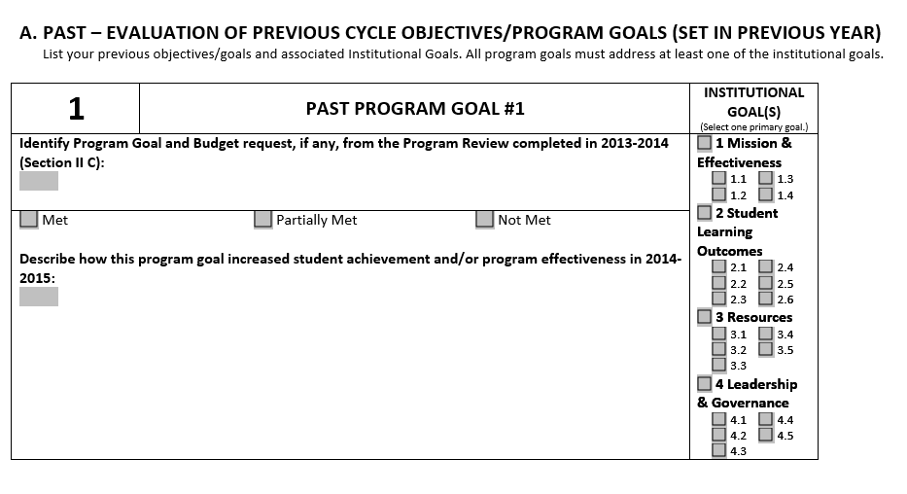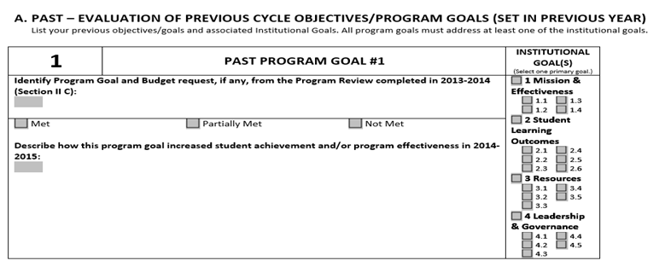
3. In SPOL, for Planning Year 2014-15 (shown below), under Accreditation click under my standards until you see the area you wish to input the Program Review:

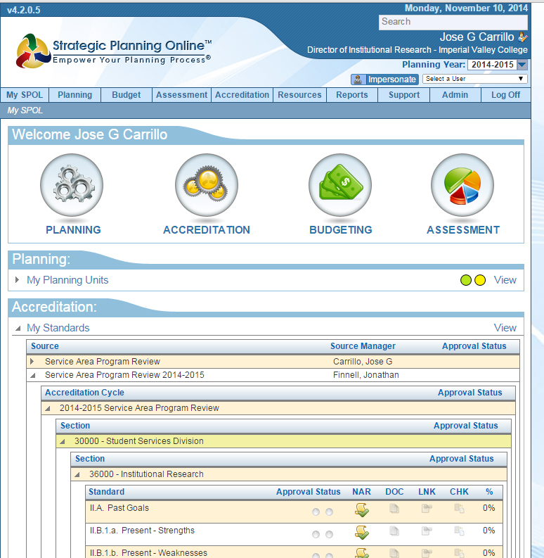
Planning year is 2014-15 for goals and present analysis
Under Accreditation, open up 2014-15 Program Review. The standards will be listed to correspond to your program review.

4. Open the past goals standard in SPOL, scroll down to the Narrative section, open and paste. Make sure all the information transfers over to SPOL, including institutional goals and basic formatting.

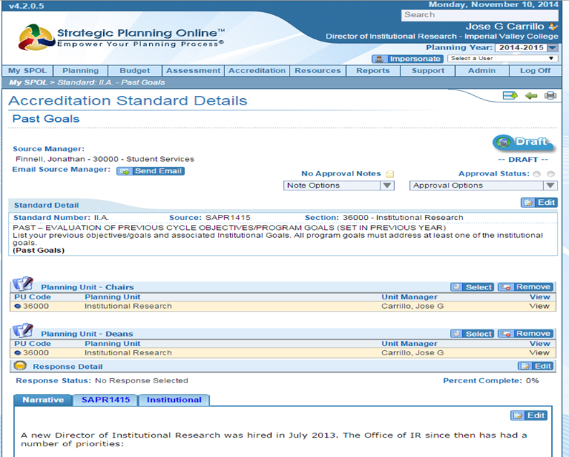

5. Proceed using the copy and paste functions for rest of the standards:
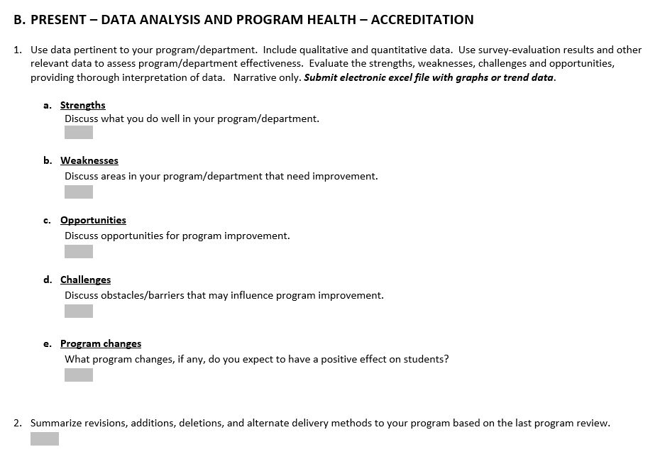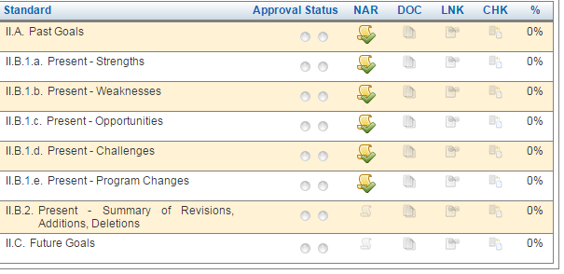
The paper format was created to match standards in SPOL, so copy each section and paste in the corresponding section in SPOL. After inputting, select submit for approval and click submit for every standard.
6. For Future Goals, change the planning year to 2015-16 in SPOL. Click on Planning tab up on the top, then click on view my objectives.
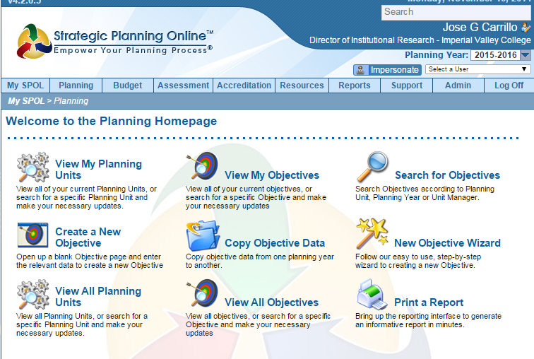

7. Click on new objective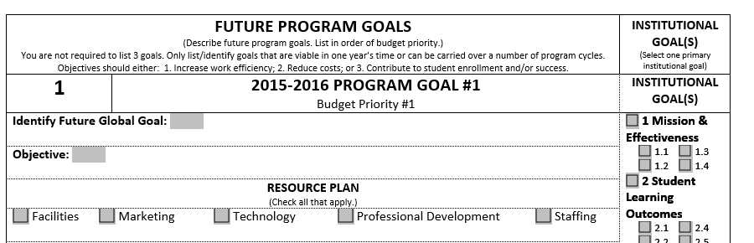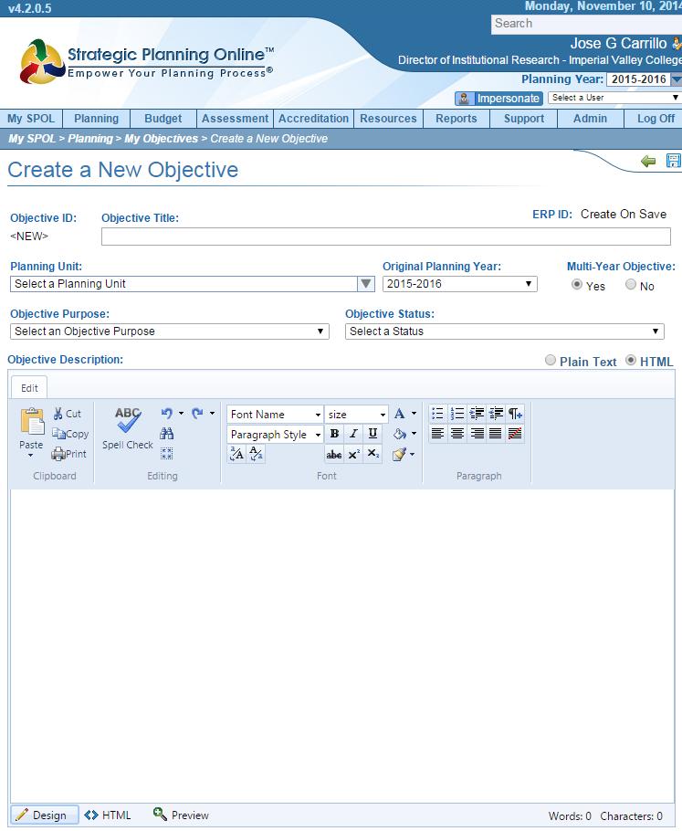
a) Copy Global goal and paste under objective title
b Copy Objective and paste under objective description
- Under planning unit chose your department or division from the dropdown menu
- If the objective will be carried out over multiple years, mark yes in SPOL
- Select Student Success for Objective Purpose
- Select current stage of the objective under objective status
- Save the objective
- Select institutional goals
- Select Resource Plan if a budget enhancement request is needed
- Select Student Success for Planning Priority
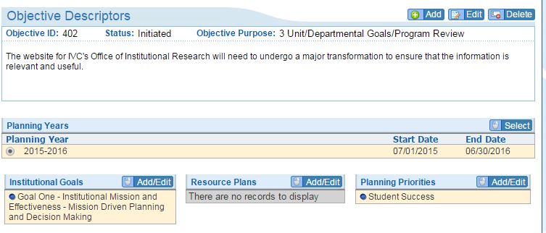
9. Tasks need to be inputted individually as they also serve as an indication for budget enhancement requests.
- 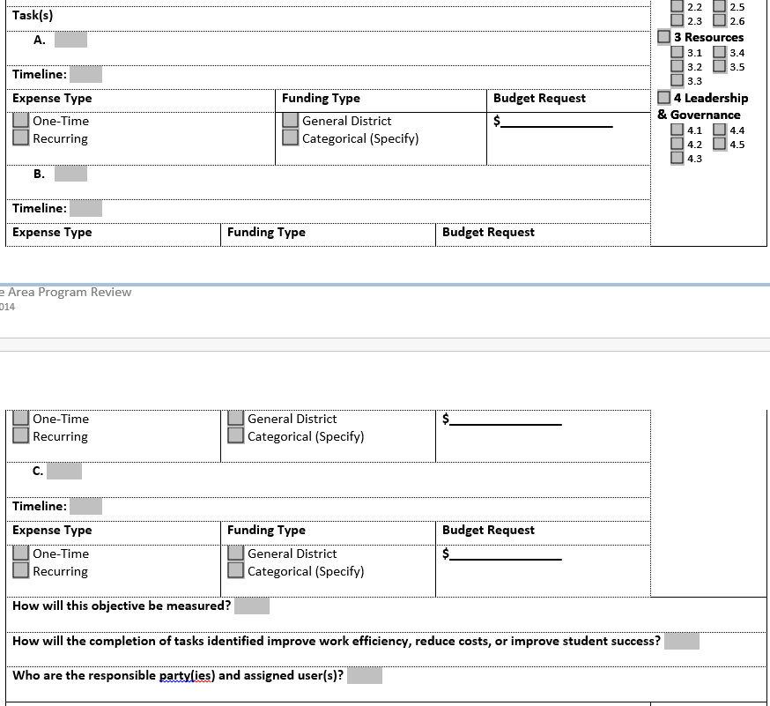
- Click on add under the tasks section, copy and paste from the hard copy
- From the paper version timeline, the first date should be the start date and the end date should be the date due. For example if Fall 2015, is listed on the timeline, start will be August 1, 2015 with and end date of December 31, 2015.
- Choose High for priority level
- Under type, choose Qualitative/Qualitative for how the objective will be measured.
- Choose status of the objective from the dropdown menu. Most will be planning unless it is a multi-year objective
- You do not need to fill in completed date nor order number.
- Click on Save.
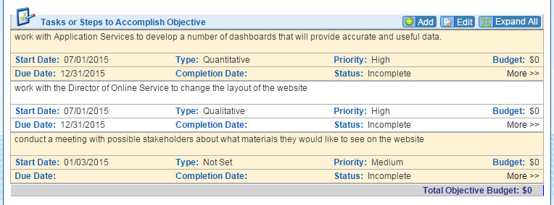

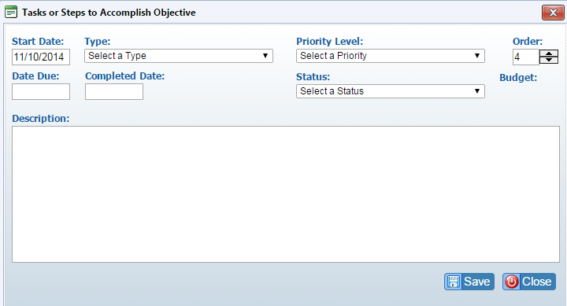
10. If there is a budget enhancement tied to this task, you need to complete the following:
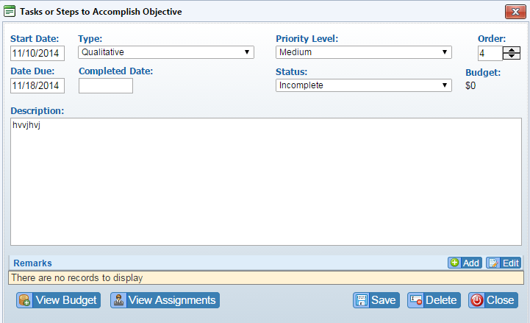
- Click on view budget
- Click on new
- Select budget account
- Select the GL code for corresponding request, if the GL code is not listed select new GL code, click next
- Under the Enhanced Budget forecast detail screen, select high for priority
- Copy and paste the task on to description
- Select the commodity type from the drop-down menu
- Select if this a classroom related expense
- Select if this is a legal requirement
- Enter the cost of the expense under the proposed section
- Enter a justification if one is stated
- Click on save

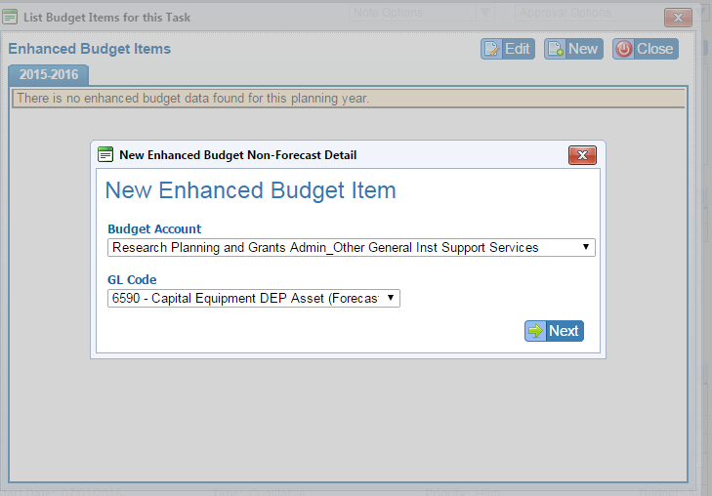

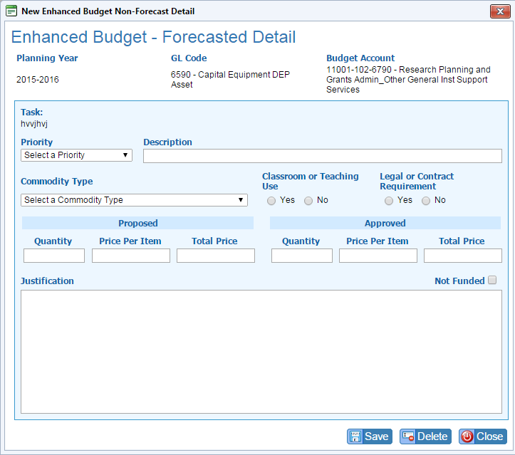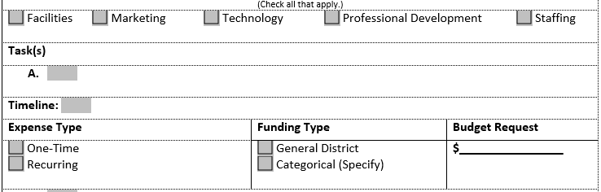
11. The rest of the questions are a direct copy and paste from the form to SPOL.
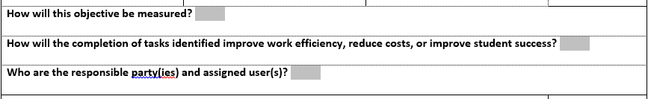

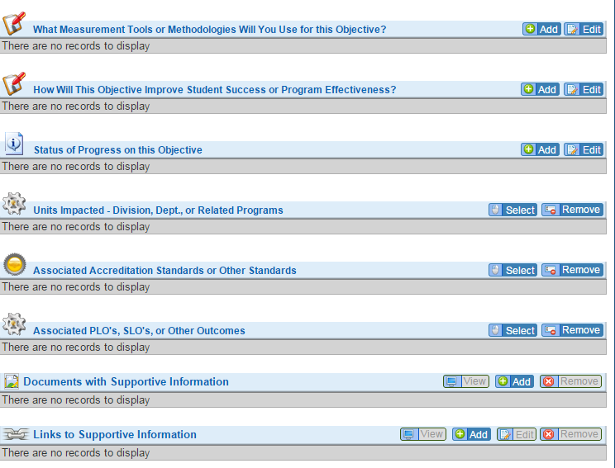

12. If you have supporting documentation to enter, click add on Documents with Supportive information. Click on the objective folder and select upload, choose your file and upload. Click on close.
13. When completed, go to the approval status options drop down menu and submit for approval.

Prioritization & Funding:

Program reviews will serve as a basis for annual prioritization, funding and budget planning. Each program/unit will submit the completed program reviews to the appropriate entity as identified in Table 1 to be incorporated into the college’s annual budget process.

The office of the Vice President for Student Services, Technology, and Research shall maintain copies of all program review reports as a permanent archive and will provide data as needed for all program review reports.

The Prioritization Process:

Each discipline/unit completes a program review for the academic year as assigned. For each resource request (budget enhancement) in the program review, a particular resource plan is identified in five categories:

• Marketing/PR
• Staffing*
• Facilities
• Professional Development
- Technology

Each program review resource request is separated out by type of need (e.g., Technology, staffing, facilities, marketing, professional development. Once compiled for the committees, the lists will be provided to the five IVC standing committees that prioritize these needs.

Institutional Level:

The following SCC Standing Committees are charged with prioritization of the following
Program Review requests:

IVC Standing Committee: | Program Review Prioritization Items:
Marketing/PR Committee | • Marketing/Public Relations Requests
Staffing Committee | - New Classified Positions  - New Administrator Positions  • New Faculty Positions*
Facilities Committee | • Facilities and Equipment Needs
Technology Committee | • Technology Needs
Campus Hour/Professional Development Committee | • Professional Development Needs

*Note: All Faculty requests are prioritized separately by the Curriculum Committee and are submitted to the Staffing Committee for inclusion in the institutional prioritization process.

Each of these committees is charged with the responsibility of developing prioritized lists of institutional needs based on program reviews submitted in that academic year.

The resource standing committees are to establish guidelines, criteria and/or rubrics for their committee’s prioritization process. Each standing committee shall discuss the process and develop the method/rubric for their prioritization process.

Standing committees are required to complete the prioritization process no later than the specified date by the EMPC.

The prioritized lists from each committee are then forwarded to the Budget and Fiscal Planning Committee, which reviews each of the committee’s prioritized lists and compiles a Master List of requests which is forwarded to the President’s Cabinet. The President’s Cabinet determines which requests will be included in the tentative budget based on budget projections for the next fiscal year.

Every spring, the following year’s deadlines are announced before April and the program review process begins again.

For 2014-2015, in order to comply with the ACCJC’s recommendation that the college show a complete planning cycle from program review to resource allocation and budget development in it’s report to the Commission by March 15, 2015, the Planning Process calendar has been compressed for 2014-2015 to have the complete process done by January 15, 2015. The Planning Calendar is shown as follows:
Table 1
Program Review Timeline and Process

Timeline | Planning Process Calendar for 2014-2015
July | • EMPC prepares for all faculty SPOL training and data entry  • Budget and Fiscal Planning prepares budget guidelines and instructions for 2015-2016 academic year  • Program Review data collected and prepared
August | • EMPC reviews Board goals/direction, EMP goals and objectives, and outlines the Program Review process for Fall 2014  • EMPC plans orientation to Fall 2014 process and requests for 2015-2016 budget  - Researcher distributes data to programs.  - Program Review starts using APR and SAPR templates.  - Budget and Fiscal Planning Committee reviews final 2014-2015 budget and forwards to President’s Cabinet.
September | • Program Review completed with Mission Objectives Budget for 2015-2016 PLOs and SLOs by September 24, 2014.  • 2014-2015 final budget is adopted by Board of Trustees
October | - Program Review reports forwarded to Deans for approval by 10/03/2014.  - Program Review reports forwarded to VPs for approval by 10/10/2014.  - Resource requests forwarded to all Resource Planning committees via SPOL by 10/17/2014.  - Resource Planning committees prioritize all requests and forward to Budget and Fiscal Planning and CBO via SPOL by 10/24/2014.  - Budget and Fiscal Planning Committee prioritizes all resource requests and forwards to President’s Cabinet by 10/31/2014.
November | • President’s Cabinet finalizes all resources requests by 11/18/2014.
January | - Preliminary Budget for 2015-2016, and projections for 201602017 and 2017-2018 developed from information within SPOL by 1/20/2015.  - EMPC evaluation of processes completed by 1/30/2015.

Data

Units base their program review on a variety of types of data and sources of data, including, but not limited to:
• Student tracking trends
• Course enrollment trends
• Section count trends
• Student demographic trends
• Student success trends
• Student survey
• Point‐of‐service surveys
• Labor market information
• Environmental scan information

Data Definitions

CATEGORY TERM DESCRIPTION
Enrollment Headcount Student headcount is an unduplicated count of students who are active in a credit class on census day. It is the number of individual students taking classes. Students may enroll in one more courses in a term, but each student is counted only once for the term.

Enrollment Student enrollment is a duplicated count of students. Students may be enrolled in more than one course. Each enrollment for which there is a transcript notation is counted for the term.
Census The day on which active enrollment is counted for the purpose of computing FTES, the basis for State funding. Census for term‐ length classes is Monday of the 3rd week of classes.
Census Enrollment Enrollment on census day.

Full‐Time Equivalent
Student (FTES)
FTES is a standard statewide measure of student enrollment at an academic department, or an institution. FTES is a key performance indicator, productivity measure, and funding rate. FTES represents neither student headcount nor student enrollment, but it is a conceptual measure of student enrollment. The formula to calculate FTES is expressed by the equation below:

Full‐Time Equivalent
Faculty (FTEF)
FTES = (Census enrollment X Weekly student contact hours X Term Length Multiplier) / 525 where TLM = 16.5

Example: FTES for a 3 unit class with 30 students enrolled at census FTES = (30 x 3.38 hours/week x 16.5 weeks/semester) /
525 = 3.19

In a FTEF, a faculty member’s actual workload is standardized against the teaching load. Thus, FTEF does not represent an actual number of faculty members; it is a conceptual measure workload at an academic department, or an institution. The formula to calculate FTEF is expressed by the equation below:

FTEF = WFCH / Contract teaching load of the discipline where
WFCH = standard course hours Example: 3/15 = 0.20
Regular FTEF ‐ FTEF in sections taught by regular, full‐time faculty
Adjunct FTEF ‐ FTEF in sections taught by adjunct faculty
Hourly FTEF ‐ FTEF in sections taught as an overload by regular faculty

CATEGORY TERM DESCRIPTION

Weekly Student Contact Hours (WSCH)

Instructional
Efficiency
WSCH is acronym for weekly student contact hours. It presents a total number of hours faculty contacted students weekly in an academic department or an institution.
WSCH = census enrollment x class hours per week
WSCH is a proxy for revenue generated by the class. FTEF is a proxy for instructional cost. The ratio, WSCH per FTEF could be interpreted in terms of cost‐efficiency or instructional quality. District has established 510 as the target WSCH/FTEF standard.

Average Class Size ACS is a measure of the enrollment per section.

Mode of
Instructional Delivery
Classroom ‐ Traditional classes offered 'on ground' in a classroom

Hybrid ‐ Classes that are offered both online and in the classroom.

Student Achievement Outcomes

Online ‐ Web‐based classes
Section Count The number of sections offered, including combined classes counted separately.
Success Rate The percentage of students who received a passing grade of A, B, C, P at the end of the semester.

Success rate = (A,B,C,P)/(A,B,C,D,F,P,N,W,I)
Retention Rate The percentage of students retained in a class at the end of the semester.

Retention rate = (A,B,C,D,F,N,P,I)/(A,B,C,D,F,P,N,I,W)
Persistence Rate (number of students with at least one course in next term) /
(number of students with at least one course in The first term)
Degrees Associate of Arts and Associate of Science
Certificate Awards requiring 18 or more units
Skill Certificate Awards requiring fewer than 18 units
Division Academic division that includes one or more disciplines/subjects
Program The program in which an award is earned by a student

CATEGORY TERM DESCRIPTION

Expenditure and Budget
Fiscal Year July 1 ‐ June 30

AY (Academic Year) Summer ‐ Fall ‐ Winter ‐ Spring

Restricted and
Categorical Funds
Funds restricted to a particular categorical program or grant

Unrestricted Funds Funds comprising the general fund of the college
Actual Expenditures Expenses according to the year‐end closing as reported in the
Final Budget
Budget Final Budget adopted by the Board

S.M.A.R.T. Goals

Creating S.M.A.R.T. Goals

Specific
Measurable
Attainable
Realistic
Time Bound

Specific: A specific goal has a much greater chance of being accomplished than a general goal. To set a specific goal you must answer the six “W” questions:

*Who: Who is involved?
*What: What do I want to accomplish?
*Where: Identify a location.
*When: Establish a time frame.
*Which: Identify requirements and constraints.
*Why: Specific reasons, purpose or benefits of accomplishing the goal.

EXAMPLE: A general goal would be, “Get in shape.” But a specific goal would say, “Join a health club and workout 3 days a week.”

Measurable - Establish concrete criteria for measuring progress toward the attainment of each goal you set.

When you measure your progress, you stay on track, reach your target dates, and experience the exhilaration of achievement that spurs you on to continued effort required to reach your goal.

To determine if your goal is measurable, ask questions such as……

How much? How many?

How will I know when it is accomplished?

Attainable – When you identify goals that are most important to you, you begin to figure out ways you can make them come true. You develop the attitudes, abilities, skills, and financial capacity to reach them. You begin seeing previously overlooked opportunities to bring yourself closer to the achievement of your goals.

You can attain most any goal you set when you plan your steps wisely and establish a time frame that allows you to carry out those steps. Goals that may have seemed far away and out of reach eventually move closer and become attainable, not because your goals shrink, but because you grow and expand to match them. When you list your goals you build your self-image. You see yourself as worthy of these goals, and develop the traits and personality that allow you to possess them.

Realistic- To be realistic, a goal must represent an objective toward which you are both willing and able to work. A goal can be both high and realistic; you are the only one who can decide just how high your goal should be. But be sure that every goal represents substantial progress.

A high goal is frequently easier to reach than a low one because a low goal exerts low motivational force. Some of the hardest jobs you ever accomplished actually seem easy simply because they were a labor of love.

Time Bound – A goal should be grounded within a time frame. With no time frame tied to it there’s no sense of urgency. If you want to lose 10 lbs, when do you want to lose it by? “Someday” won’t work. But if you anchor it within a timeframe, “by May 1st”, then you’ve set your unconscious mind into motion to begin working on the goal.

Your goal is probably realistic if you truly believe that it can be accomplished. Additional ways to know if your goal is realistic is to determine if you have accomplished anything similar in the past or ask yourself what conditions would have to exist to accomplish this goal.

T can also stand for Tangible – A goal is tangible when you can experience it with one of the senses, that is, taste, touch, smell, sight or hearing.

When your goal is tangible you have a better chance of making it specific and measurable and thus attainable.

Source: Top Achievement Self Improvement and Personal Development Community http://topachievement.com/smart.html

Legal and Professional Basis for Program Review

TITLE 5, Section 51022(a)

The governing board of each community college district shall, no later than July 1, 1984, develop, file with the Chancellor, and carry out its policies for the establishment, modification, or discontinuance of courses or programs. Such policies shall incorporate statutory responsibilities regarding vocational or occupational training program review as specified in section 78016 of the Education Code.

ACCJC STANDARDS

Standard 1B. Improving Institutional Effectiveness

The institution demonstrates a conscious effort to produce and support student learning, measures that learning, assesses how well learning is occurring, and makes changes to improve student learning. The institution also organizes its key processes and allocates its resources to effectively support student learning. The institution demonstrates its effectiveness by providing 1) evidence of the achievement of student learning outcomes and 2) evidence of institution and program performance. The institution uses ongoing and systematic evaluation and planning to refine its key processes and improve student learning.

1. The institution maintains an ongoing, collegial, self‐reflective dialogue about the continuous improvement of student learning and institutional processes.
2. The institution sets goals to improve its effectiveness consistent with its stated purposes. The institution articulates its goals and states the objectives derived from them in measurable terms so that the degree to which they are achieved can be determined and widely discussed. The institutional members understand these goals and work collaboratively toward their achievement.
3. The institution assesses progress toward achieving its stated goals and makes decisions regarding the improvement of institutional effectiveness in an ongoing and systematic cycle of evaluation, integrated planning, resource allocation, implementation, and re‐evaluation. Evaluation is based on analyses of both quantitative and qualitative data.
4. The institution provides evidence that the planning process is broad‐based, offers opportunities for input by appropriate constituencies, allocates necessary resources, and leads to improvement of institutional effectiveness.
5. The institution uses documented assessment results to communicate matters of quality assurance to appropriate constituencies.
6. The institution assures the effectiveness of its ongoing planning and resource allocation processes by systematically reviewing and modifying, as appropriate, all parts of the cycle, including institutional and other research efforts.

The institution assesses its evaluation mechanisms through a systematic review of their effectiveness in improving instructional programs, student support services, and library and other learning support services.

ACCJC Rubric for Evaluating Institutional Effectiveness – Part I: Program Review

Accrediting Commission for Community and Junior Colleges
Western Association of Schools and Colleges

Levels of  Implementation | Characteristics of Institutional Effectiveness in Planning  (Sample Institutional Behaviors)
Awareness | - There is preliminary investigative dialogue at the institution or within some departments about what data or process should be used for program review.  - There is recognition of existing practices and models in program review that make use of institutional research.  - There is exploration of program review models by various departments or individuals.  - The college is implementing pilot program review models in a few programs/operational units.
Development | - Program review is embedded in practice across the institution using qualitative and quantitative data to improve program effectiveness.  - Dialogue about the results of program review is evident within the program as part of discussion of program effectiveness.  - Leadership groups throughout the institution accept responsibility for program review framework development (Senate, Admin., Etc.)  - Appropriate resources are allocated to conducting program review of meaningful quality.  - Development of a framework for linking results of program review to planning for improvement.  - Development of a framework to align results of program review to resource allocation.
Proficiency | - Program review processes are in place and implemented regularly.  - Results of all program reviews are integrated into institution-wide planning for improvement and informed decision-making.  - The program review framework is established and implemented.  - Dialogue about the results of all program reviews is evident throughout the institution as part of discussion of institutional effectiveness.  - Results of program review are clearly and consistently linked to institutional planning processes and resource allocation processes; college can demonstrate or provide specific examples.  - The institution evaluates the effectiveness of its program review processes in supporting and improving student achievement and student learning outcomes.
Sustainable  Continuous  Quality  Improvement | - Program review processes are ongoing, systematic and used to assess and improve student learning and achievement.  - The institution reviews and refines its program review processes to improve institutional effectiveness.  - The results of program review are used to continually refine and improve program practices resulting in appropriate improvements in student achievement and learning.

ACCJC Rubric for Evaluating Institutional Effectiveness- Part I: Program Review

Accrediting Commission for Community and Junior Colleges
Western Association of Schools and Colleges

Rubric for Evaluating Institutional Effectiveness- Part II: Planning
(See cover letter for how to use this rubric.)

Levels of  Implementation | Characteristics of Institutional Effectiveness in Planning  (Sample Institutional Behaviors)
Awareness | - The college has preliminary investigative dialogue about planning processes.  - There is recognition of case need for quantitative and qualitative data and analysis in planning.  - The college has initiated pilot projects and efforts in developing systematic cycle of evaluation, integrated planning and implementation (e.g. in human or physical resources).  - Planning found in only some areas of college operations.  - There is exploration of models and definitions and issues related to planning.  - There is minimal linkage between plans and a resource allocation process, perhaps planning for use of "new money".  - The college may have a consultant-supported plan for facilities, or a strategic plan.
Development | - The Institution has defined a planning process and assigned responsibility for implementing it.  - The Institution has identified quantitative and qualitative data and is using it.  - Planning efforts are specifically linked to institutional mission and goals.  - The Institution uses applicable quantitative data to improve institutional effectiveness in some areas of operation.  - Governance and decision-making processes incorporate review of institutional effectiveness in mission and plans for improvement.  - Planning processes reflect the participation of a broad constituent base.
Proficiency | - The college has a well documented, ongoing process for evaluating itself in all areas of operation, analyzing and publishing the results and planning and implementing improvements.  - The institution's component plans are integrated into a comprehensive plan to achieve broad educational purposes and improve institutional effectiveness.  - The institution effectively uses its human, physical, technology, and financial resources to achieve its broad educational purposes, including stated student learning outcomes.  - The college has documented assessment results and communicated matters of quality assurance to appropriate constituencies (documents data and analysis of achievement of its educational mission).  - The institution assesses progress toward achieving its education goals over time (uses longitudinal data and analyses).  - The institution plans and effectively incorporates results of program review in all areas of educational services: instruction, support services, library and learning resources.
Sustainable Continuous Quality Improvement | - The institution uses ongoing and systematic evaluation and planning to refine its key processes and improve student learning.  - There is dialogue about institutional effectiveness that is ongoing, robust and pervasive; data and analyses are widely distributed and used throughout the institution.  - There is ongoing review and adaptation of evaluation and planning processes.  - There is consistent and continuous commitment to improving student learning; and educational effectiveness is a demonstrable priority in all planning structures and processes.

